**Project Report** **On**

**Cab fare Prediction**

-D.Sowmya

**INDEX**

**Chapter1 INTRODUCTION**

1.1 Problem Statement

1.2 Data

**Chapter2**   **METHODOLOGY**

• Pre-Processing

• Modelling

• Model Selection

**Chapter3 PRE PROCESSING**

3.1 Data exploration and Cleaning (Missing Values and Outliers)

3.2 Creating some new variables from the given variables

3.3 Selection of variables

3.4 Some more data exploration

• Dependent and Independent Variables

• Uniqueness of Variables

• Dividing the variables

3.5 Feature Scaling

**Chapter4 MODELLING**

4.1 Linear Regression

4.2 Decision Tree

4.3 Random Forest

4.4 Gradient Boosting

4.5 Hyper Parameters Tunings for optimizing the results

**Chapter5 CONCLUSION**

5.1 Model Evaluation

5.2 Model Selection

5.3 Some Visualization facts

REFERENCES :

APPENDIX :

**Chapter 1**

**Introduction**

Now a day’s cab rental services are expanding with the multiplier rate. Car rentals are an option the more and more used by travellers especially in the XXI century. Low cost airlines allow us to travel to any city of the world for very little money. Now you can move from one location to another and discover many places for very little money. The ease of using the services and flexibility gives their customer a great experience with competitive prices.

* 1. **Problem Statement**

You are a cab rental start-up company. You have successfully run the pilot project and now want to launch your cab service across the country. You have collected the historical data from your pilot project and now have a requirement to apply analytics for fare prediction. You need to design a system that predicts the fare amount for a cab ride in the city.

**1.2 Data**

Understanding of data is the very first and important step in the process of finding solution of any business problem. Here in our case our company has provided a data set with following features, we need to go through each and every variable of it to understand and for better functioning. Size of Dataset Provided: - 16067 rows, 7 Columns (including dependent variable) Missing Values: Yes

Outliers Presented: Yes

Below mentioned is a list of all the variable names with their meanings:

|  |  |
| --- | --- |
| **Variables** | **Description** |
| fare_amount | Fare amount |
| pickup_datetime | Cab pickup date with time |
| pickup_longitude | Pickup location longitude |
| pickup_latitude | Pickup location latitude |
| dropoff_longitude | Drop location longitude |
| dropoff_latitude | Drop location latitude |
| passenger_count | Number of passengers sitting in the cab |

**Chapter 2**

**Methodology**

**➢ Pre-Processing**

When we required to build a predictive model, we require to look and manipulate the data before we start modelling which includes multiple preprocessing steps such as exploring the data, cleaning the data as well as visualizing the data through graph and plots, all these steps is combined under one shed which is **Exploratory Data Analysis**, which includes following steps:

• Data exploration and Cleaning

• Missing values treament

• Outlier Analysis

• Feature Selection

• Features Scaling

o Skewness and Log transformation

• Visualization

**➢ Modelling**

Once all the Pre-Processing steps has been done on our data set, we will now further move to our next step which is modelling. Modelling plays an important role to find out the good inferences from the data. Choice of models depends upon the problem statement and data set. As per our problem statement and dataset, we will try some models on our preprocessed data and post comparing the output results we will select the best suitable model for our problem. As per our data set following models need to be tested:

• Linear regression

• Decision Tree

• Random forest,

• Gradient Boosting

❖ We have also used hyper parameter tunings to check the parameters on which our model runs best. Following are two techniques of hyper parameter tuning we have used:

o Random Search CV

o Grid Search CV

**➢ Model Selection**

The final step of our methodology will be the selection of the model based on the different output and results shown by different models. We have multiple parameters which we will study further in our report to test whether the model is suitable for our problem statement or not.

**Chapter 3**

**Pre-Processing**

**3.1 Data exploration and Cleaning (Missing Values and Outliers)**

The very first step which comes with any data science project is data exploration and cleaning which includes following points as per this project:

a. Separate the combined variables.

b. As we know we have some negative values in fare amount so we have to remove those values.

c. Passenger count would be max 6 if it is a SUV vehicle not more than that. We have to remove the rows having passengers counts more than 6 and less than 1.

d. There are some outlier figures in the fare (like top 3 values) so we need to remove those. e. Latitudes range from -90 to 90. Longitudes range from -180 to 180. We need to remove the rows if any latitude and longitude lies beyond the ranges.

**3.2 Creating some new variables from the given variables.**

Here in our data set our variable name pickup_datetime contains date and time for pickup. So we tried to extract some important variables from pickup_datetime:

• Year

• Month

• Date

• Day of Week

• Hour

• Minute

Also, we tried to find out the distance using the haversine formula which says: The haversine formula determines the great-circle distance between two points on a sphere given their longitudes and latitudes. Important in navigation, it is a special case of a more general formula in spherical trigonometry, the law of haversines, that relates the sides and angles of spherical triangles.



So our new extracted variables are:

▪ fare_amount

▪ pickup_datetime

▪ pickup_longitude

▪ pickup_latitude

▪ dropoff_longitude

▪ dropoff_latitude

▪ passenger_

▪ year

▪ Month

▪ Date

▪ Day of Week

▪ Hour

▪ Minute

▪ Distance

**3.3 Selection of variables**

Now as we know that all above variables are of now use so we will drop the redundant variables:

▪ pickup_datetime

▪ pickup_longitude

▪ pickup_latitude

▪ dropoff_longitude

▪ dropoff_latitude

▪ Minute

Now only following variables we will use for further steps:

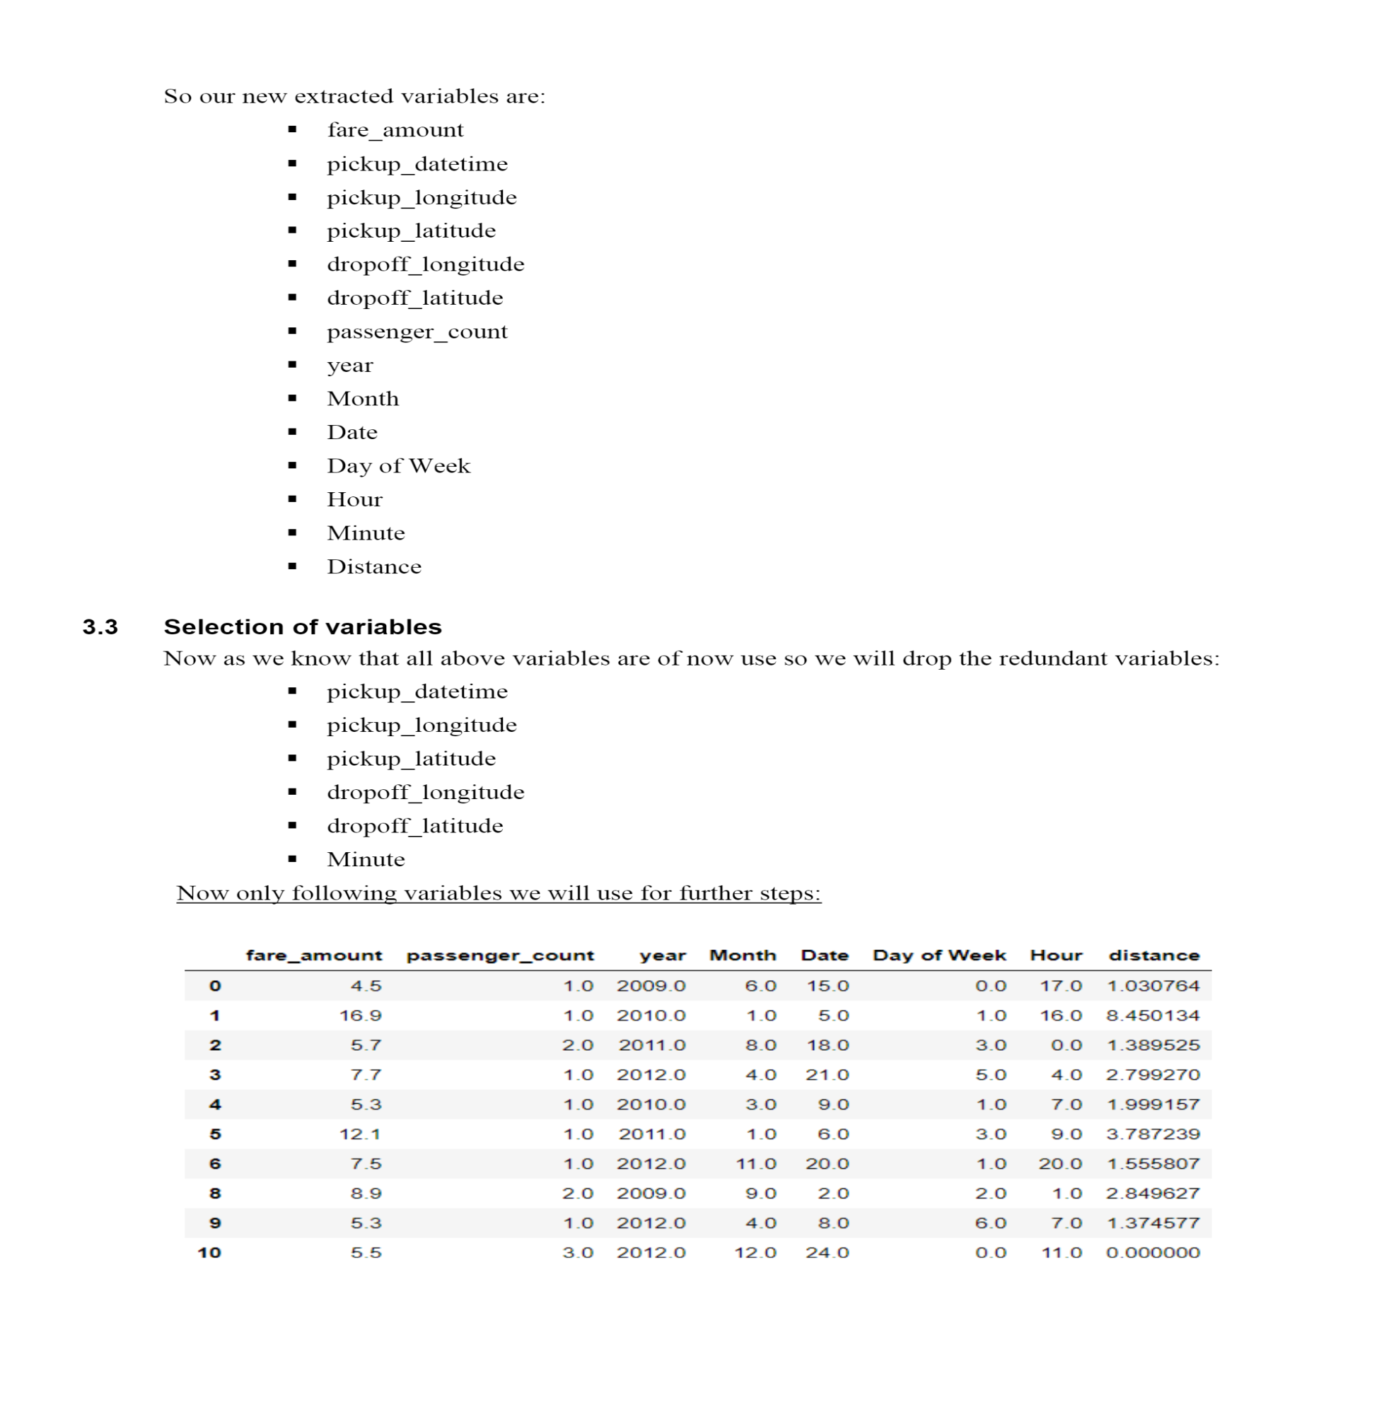

|  |  |
| --- | --- |
| **Variable Names** | **Variable Data Types** |
| fare_amount | float64 |
| passenger_count | object |
| year | object |
| Month | object |
| Date | Object |
| Day of Week | Object |
| Hour | Object |
| distance | float64 |

**3.4 Some more data exploration**

In this report we are trying to predict the fare prices of a cab rental company. So here we have a data set of 16067 observations with 8 variables including one dependent variable.

**3.4.1 Below are the names of Independent variables:**

**passenger_count, year, Month, Date, Day of Week, Hour, distance**

Our Dependent variable is: **fare_amount**

**3.4.2 Uniqueness in Variable**

We need to look at the unique number in the variables which help us to decide whether the variable is categorical or numeric. So, by using python script ‘nunique’ we tried to find out the unique values in each variable. We have also added the table below:

|  |  |
| --- | --- |
| **Variable Name** | **Unique Counts** |
| fare_amount | 450 |
| passenger_count | 7 |
| Year | 7 |
| Month | 12 |
| Date | 31 |
| Day of Week | 7 |
| Hour | 24 |
| Distance | 15424 |

**3.4.3 Dividing the variables into two categories basis their data types:**

Continuous variables - 'fare_amount', 'distance'.

Categorical Variables - 'year', 'Month', 'Date', 'Day of Week', 'Hour', 'passenger_count'

**3.5 Feature Scaling**

Skewness is asymmetry in a statistical distribution, in which the curve appears distorted or skewed either to the left or to the right. Skewness can be quantified to define the extent to which a distribution differs from a normal distribution. Here we tried to show the skewness of our variables and we find that our target variable absenteeism in hours having is one sided skewed so by using log transform technique we tried to reduce the skewness of the same.

**Below mentioned graphs shows the probability distribution plot to check distribution before log transformation:**

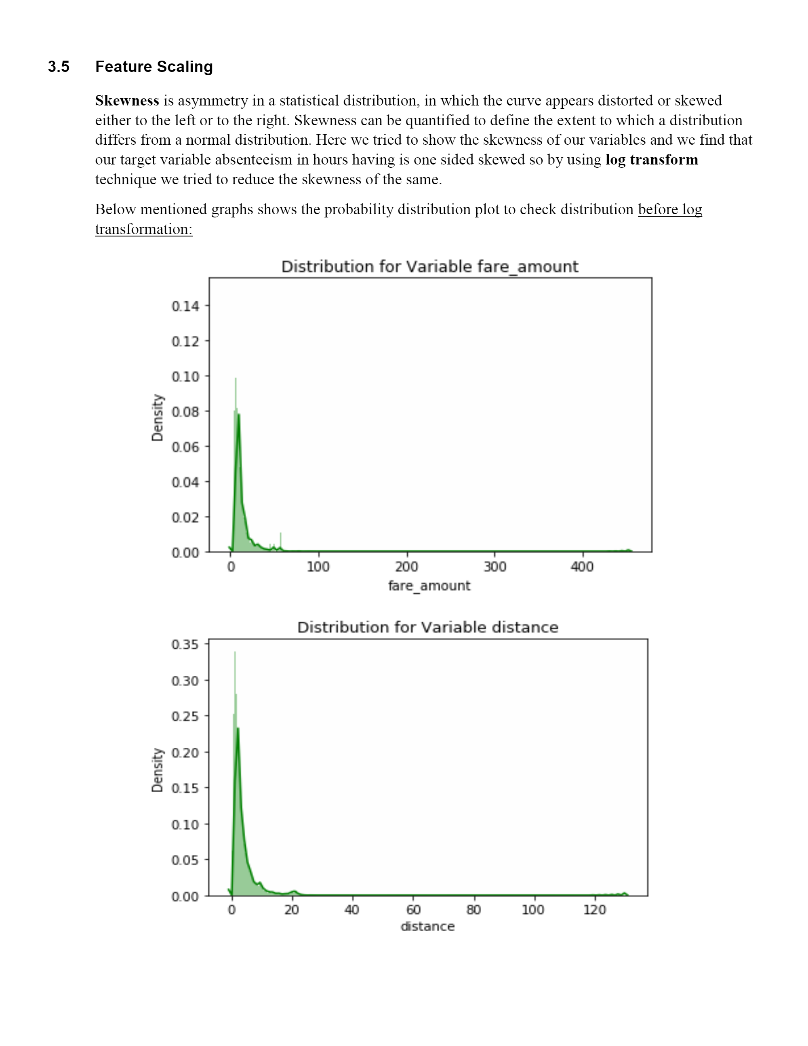

**Below mentioned graphs shows the probability distribution plot to check distribution after log transformation:**

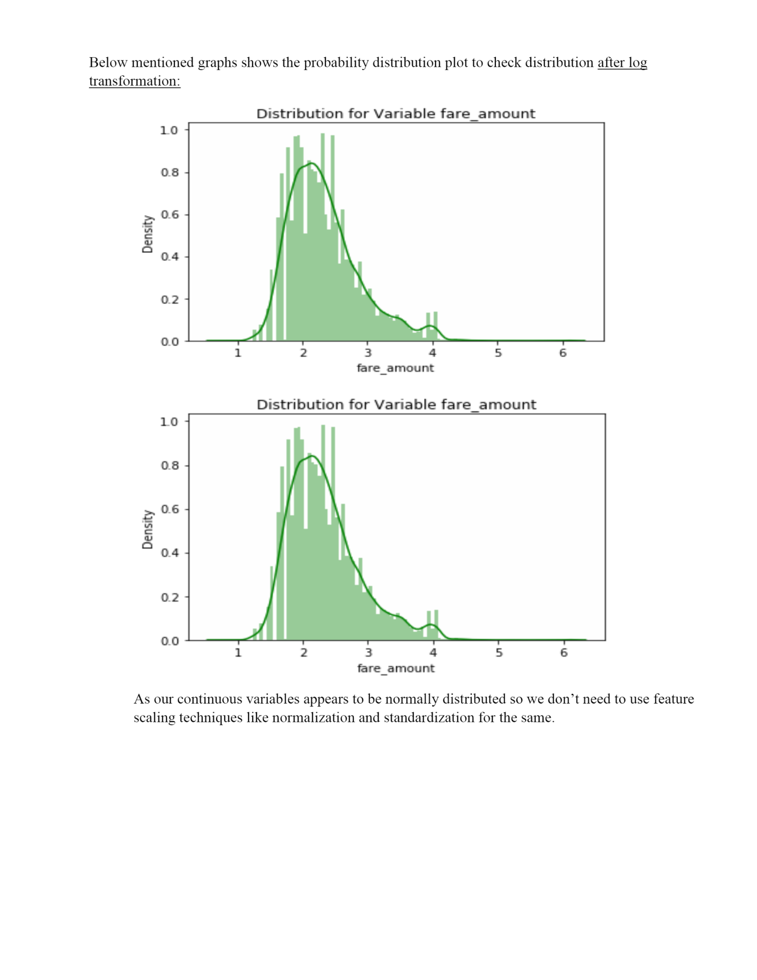

As our continuous variables appears to be normally distributed so we don’t need to use feature scaling techniques like normalization and standardization for the same.

**Chapter 4**

**Modelling**

After a thorough preprocessing, we will use some regression models on our processed data to predict the target variable. Following are the models which we have built –

Linear Regression

Decision Tree

Random Forest

Gradient Boosting

**Before running any model, we will split our data into two parts which is train and test data. Here in our case we have taken 80% of the data as our train data. Below is the snipped image of the split of train test.**

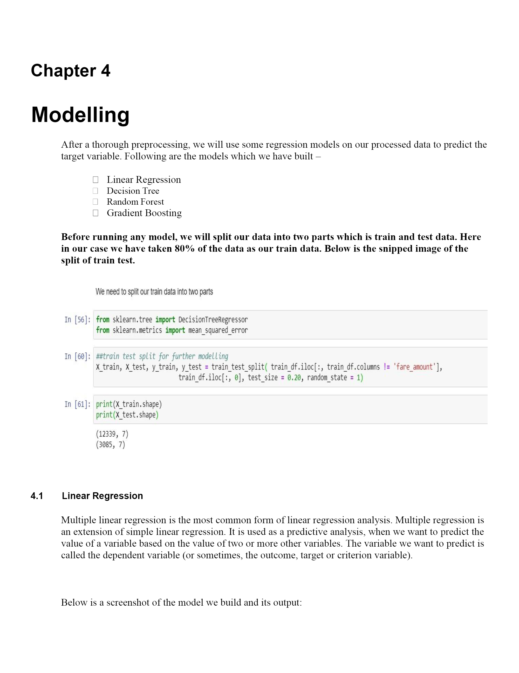

**4.1 Linear Regression**

Multiple linear regression is the most common form of linear regression analysis. Multiple regression is an extension of simple linear regression. It is used as a predictive analysis, when we want to predict the value of a variable based on the value of two or more other variables. The variable we want to predict is called the dependent variable (or sometimes, the outcome, target or criterion variable).

Below is a screenshot of the model we build and its output:

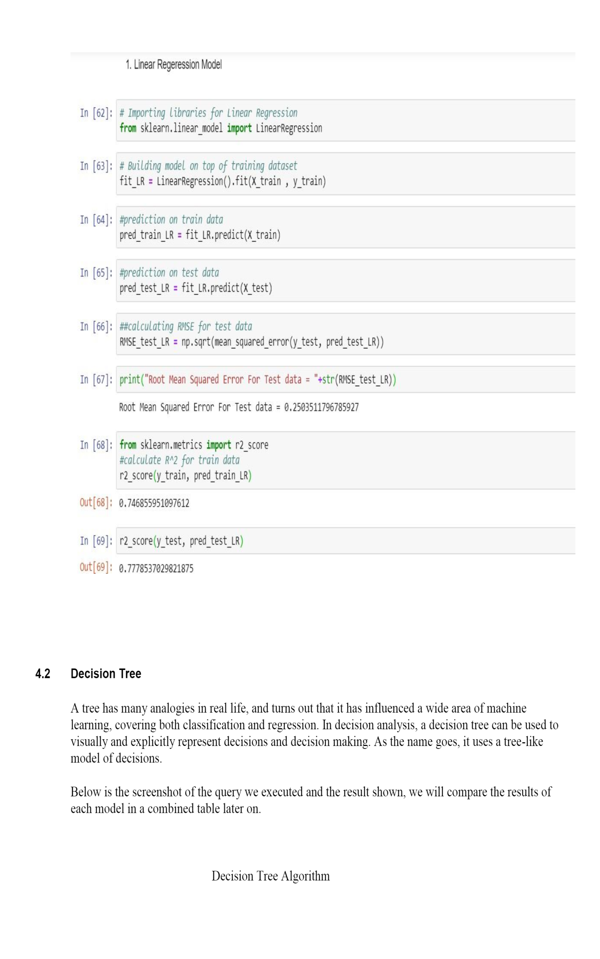

**4.2 Decision Tree**

A tree has many analogies in real life, and turns out that it has influenced a wide area of machine learning, covering both classification and regression. In decision analysis, a decision tree can be used to visually and explicitly represent decisions and decision making. As the name goes, it uses a tree-like model of decisions.

Below is the screenshot of the query we executed and the result shown, we will compare the results of each model in a combined table later on.

Decision Tree Algorithm

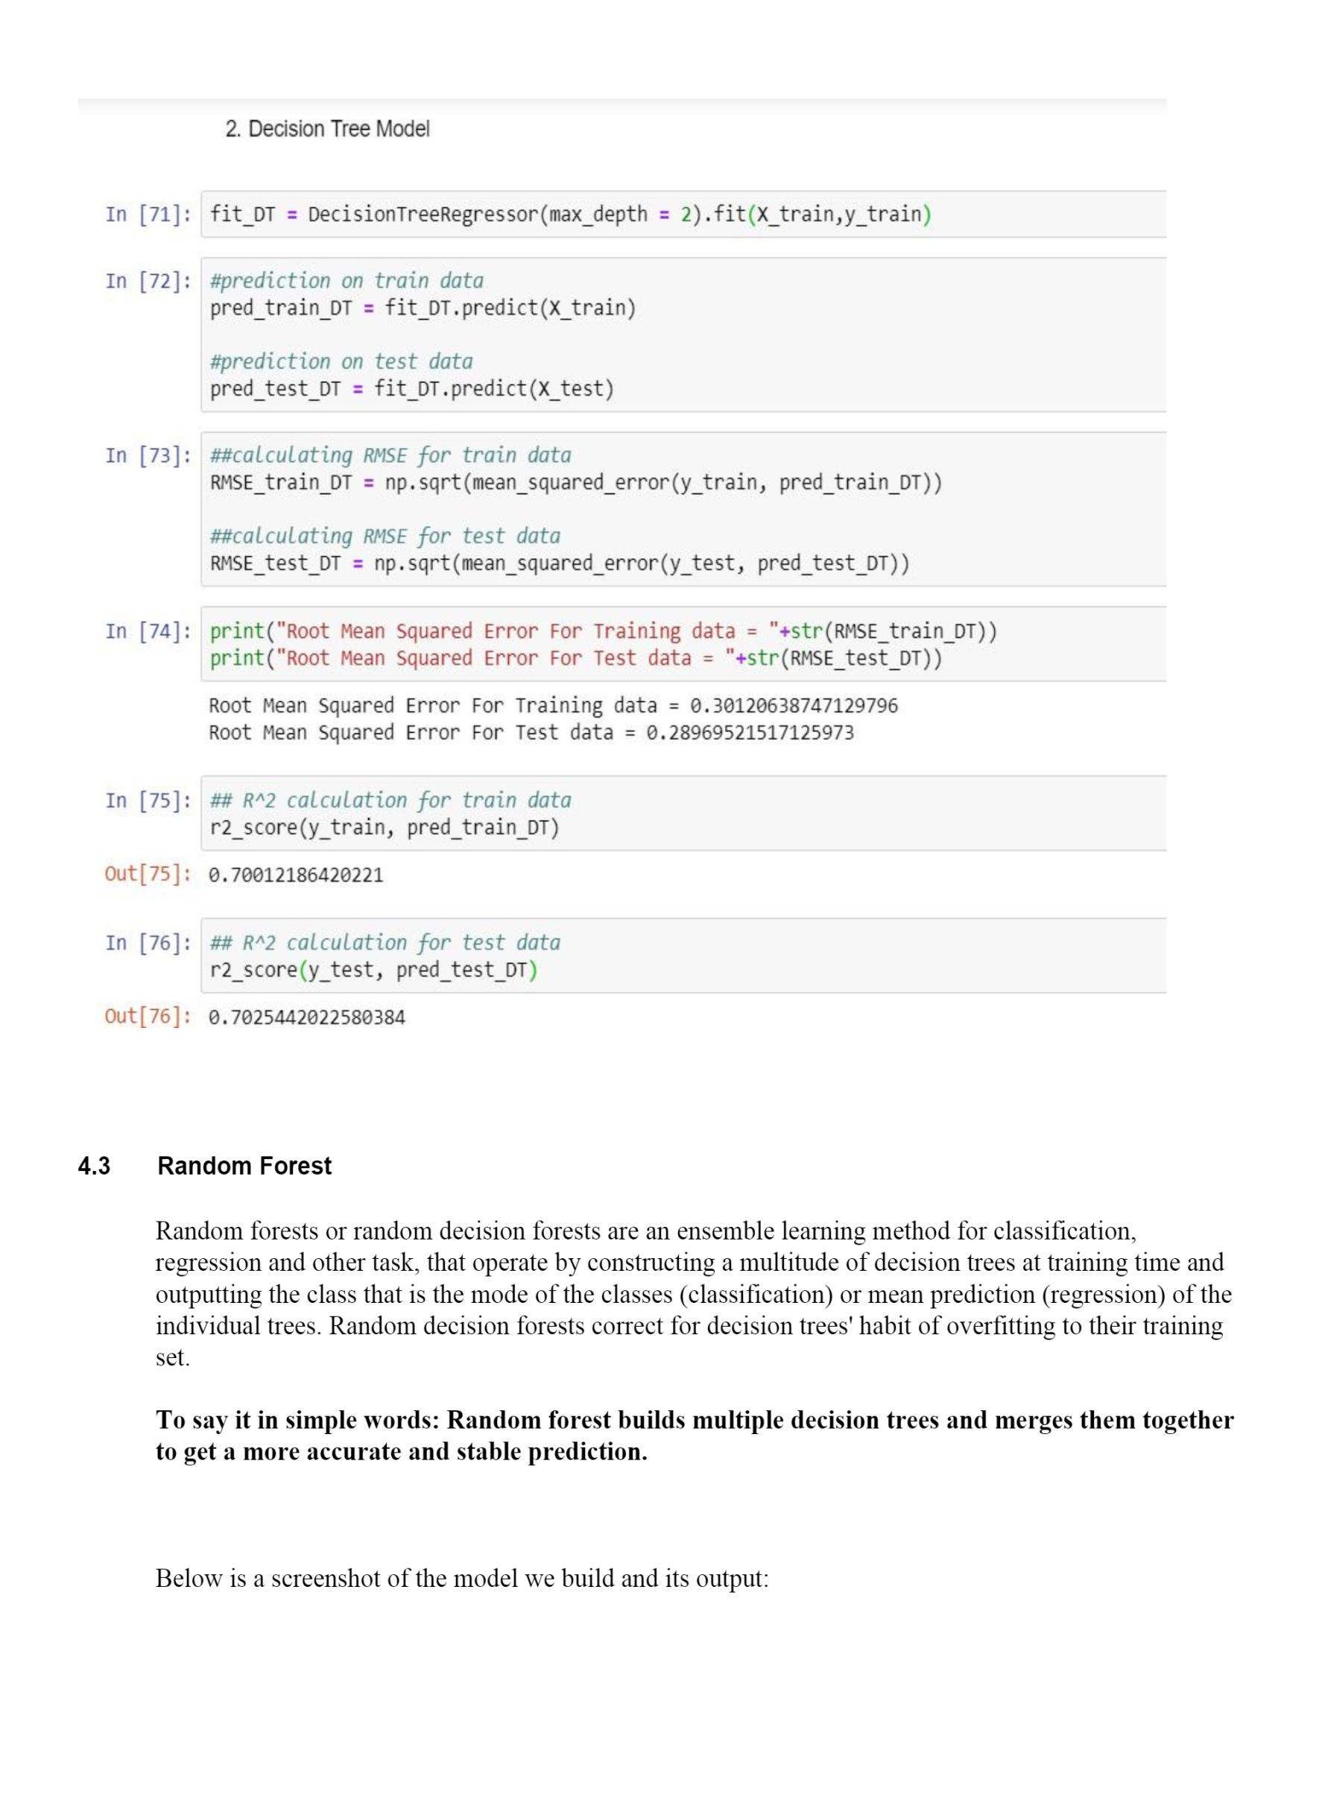

**4.3 Random Forest**

Random forests or random decision forests are an ensemble learning method for classification, regression and other task, that operate by constructing a multitude of decision trees at training time and outputting the class that is the mode of the classes (classification) or mean prediction (regression) of the individual trees. Random decision forests correct for decision trees' habit of overfitting to their training set.

To say it in simple words: Random forest builds multiple decision trees and merges them together to get a more accurate and stable prediction.

Below is a screenshot of the model we build and its output:

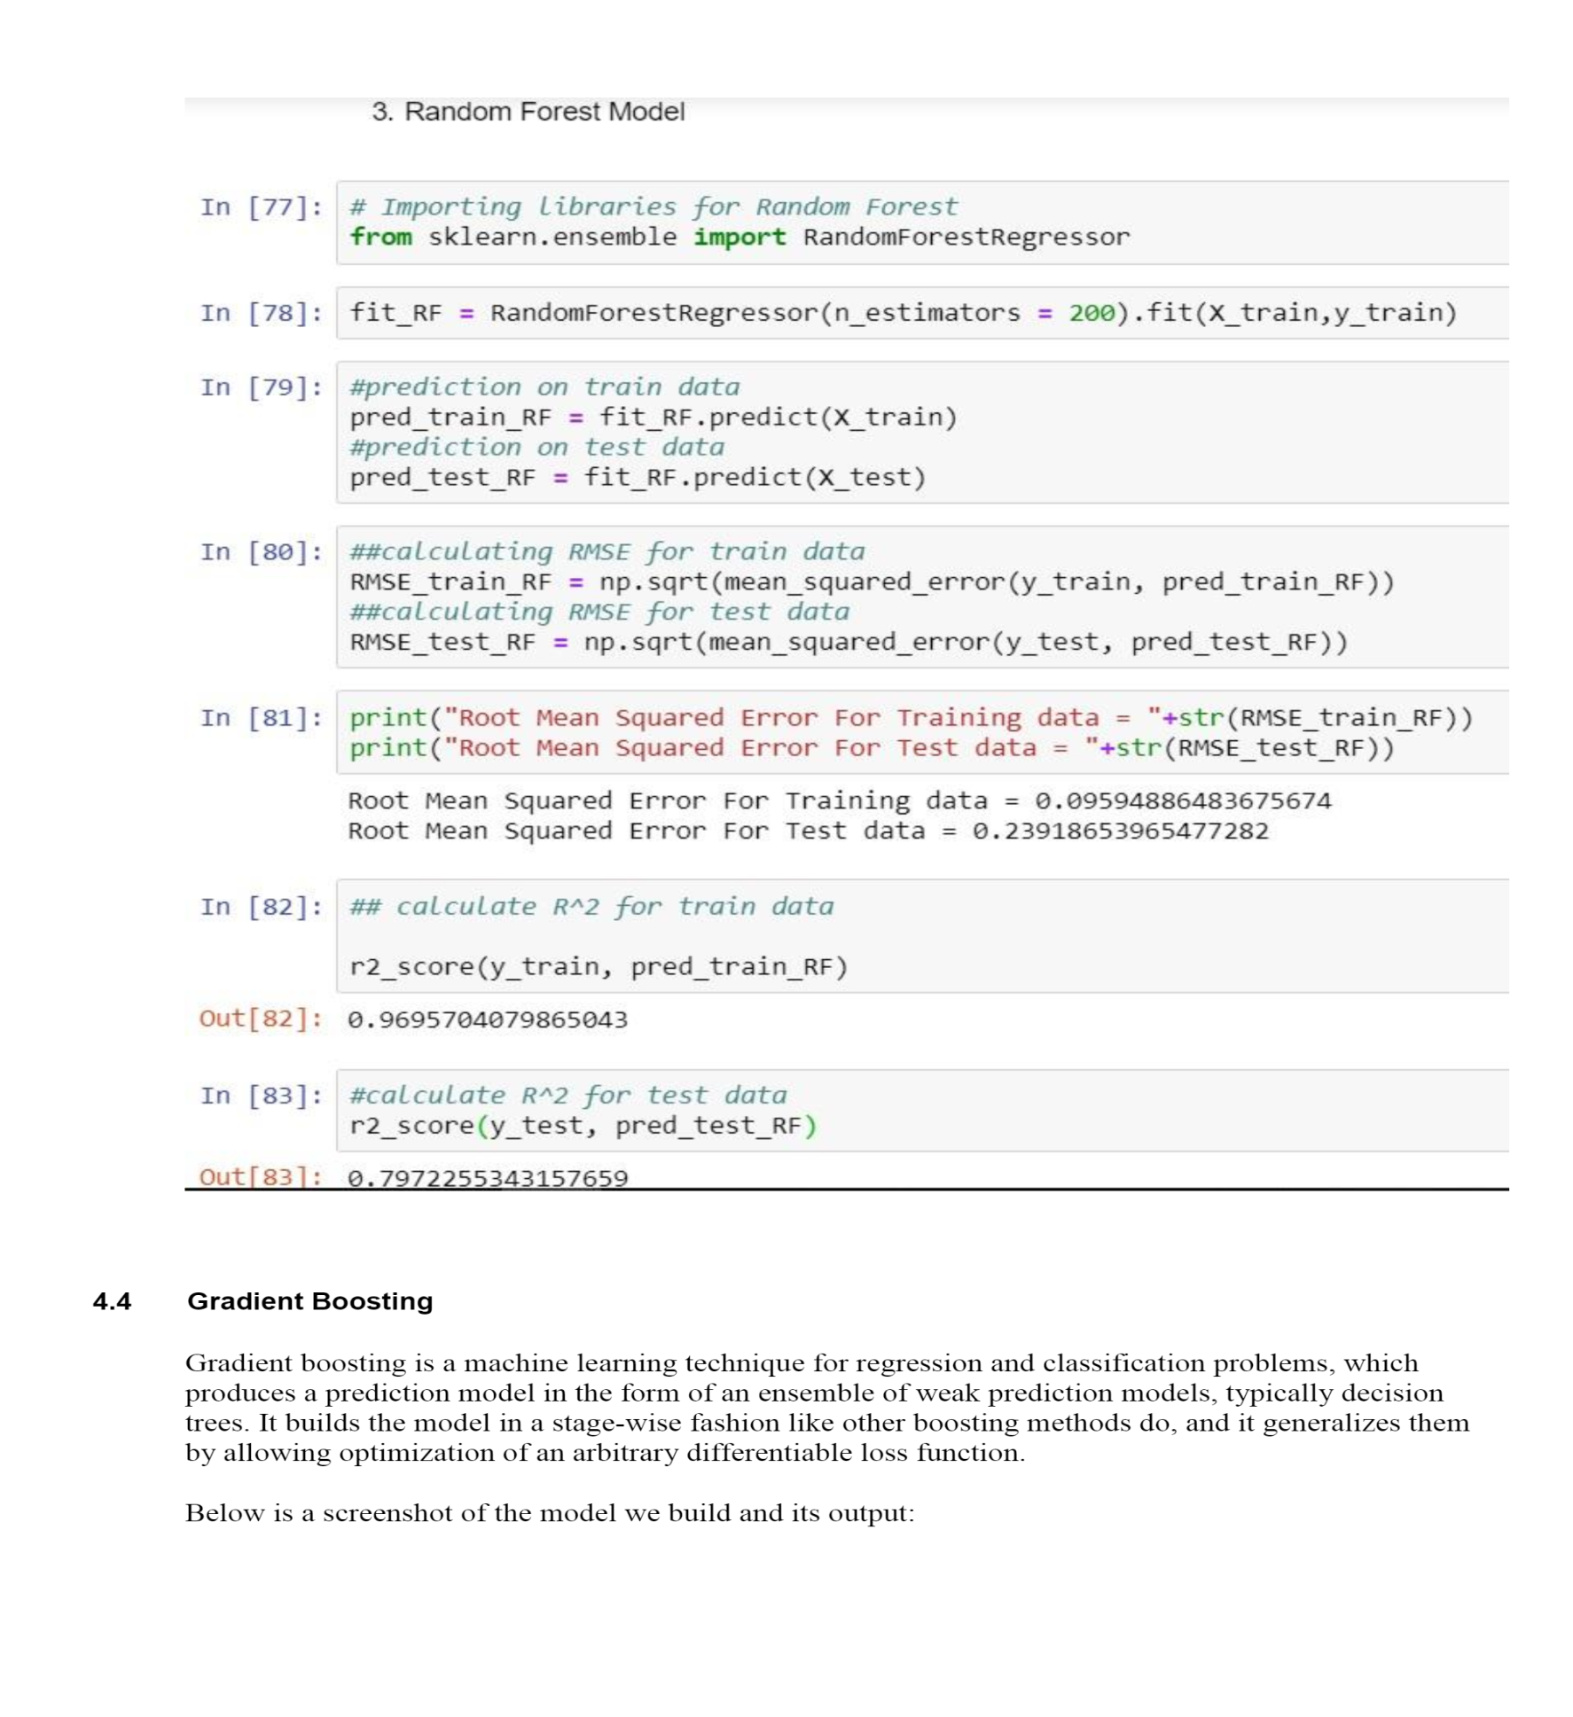

**4.4 Gradient Boosting**

Gradient boosting is a machine learning technique for regression and classification problems, which produces a prediction model in the form of an ensemble of weak prediction models, typically decision trees. It builds the model in a stage-wise fashion like other boosting methods do, and it generalizes them by allowing optimization of an arbitrary differentiable loss function.

Below is a screenshot of the model we build and its output:

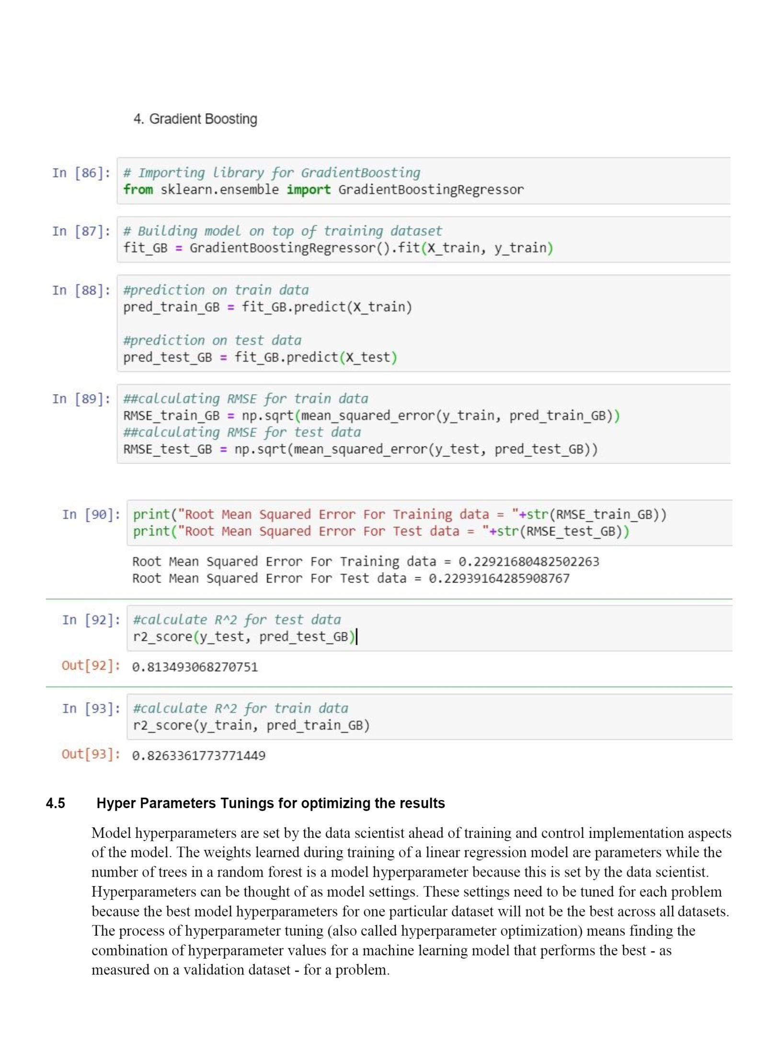

**4.5 Hyper Parameters Tunings for optimizing the results**

Model hyperparameters are set by the data scientist ahead of training and control implementation aspects of the model. The weights learned during training of a linear regression model are parameters while the number of trees in a random forest is a model hyperparameter because this is set by the data scientist. Hyperparameters can be thought of as model settings. These settings need to be tuned for each problem because the best model hyperparameters for one particular dataset will not be the best across all datasets. The process of hyperparameter tuning (also called hyperparameter optimization) means finding the combination of hyperparameter values for a machine learning model that performs the best - as measured on a validation dataset - for a problem.

Here we have used two hyper parameters tuning techniques

➢ Random Search CV

➢ Grid Search CV

1. **Random Search CV:** This algorithm set up a grid of hyperparameter values and select random combinations to train the model and score. The number of search iterations is set based on time/resources.

2. **Grid Search CV**: This algorithm set up a grid of hyperparameter values and for each combination, train a model and score on the validation data. In this approach, every single combination of hyperparameters values is tried which can be very inefficient.

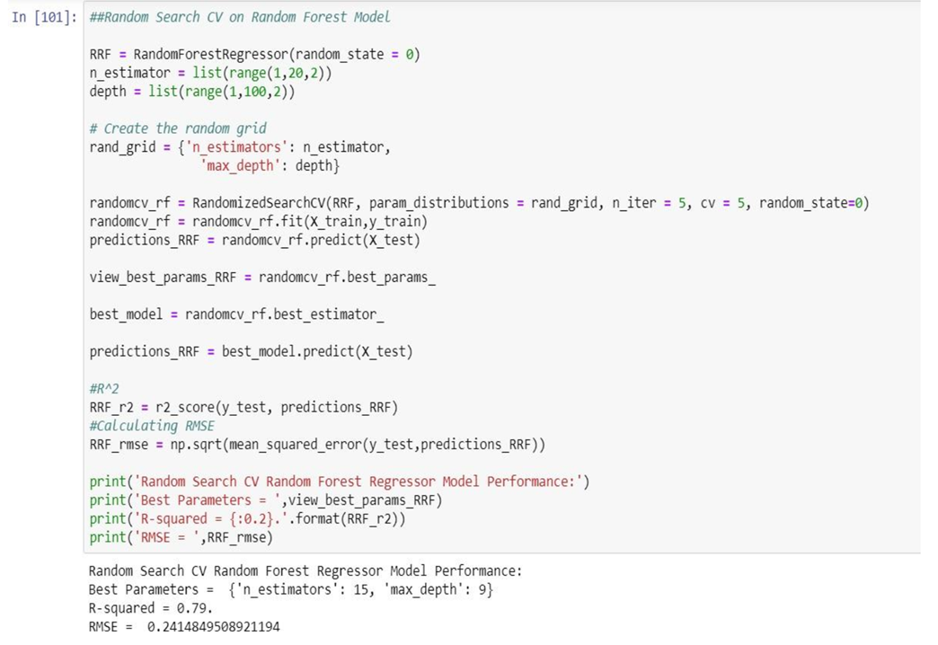

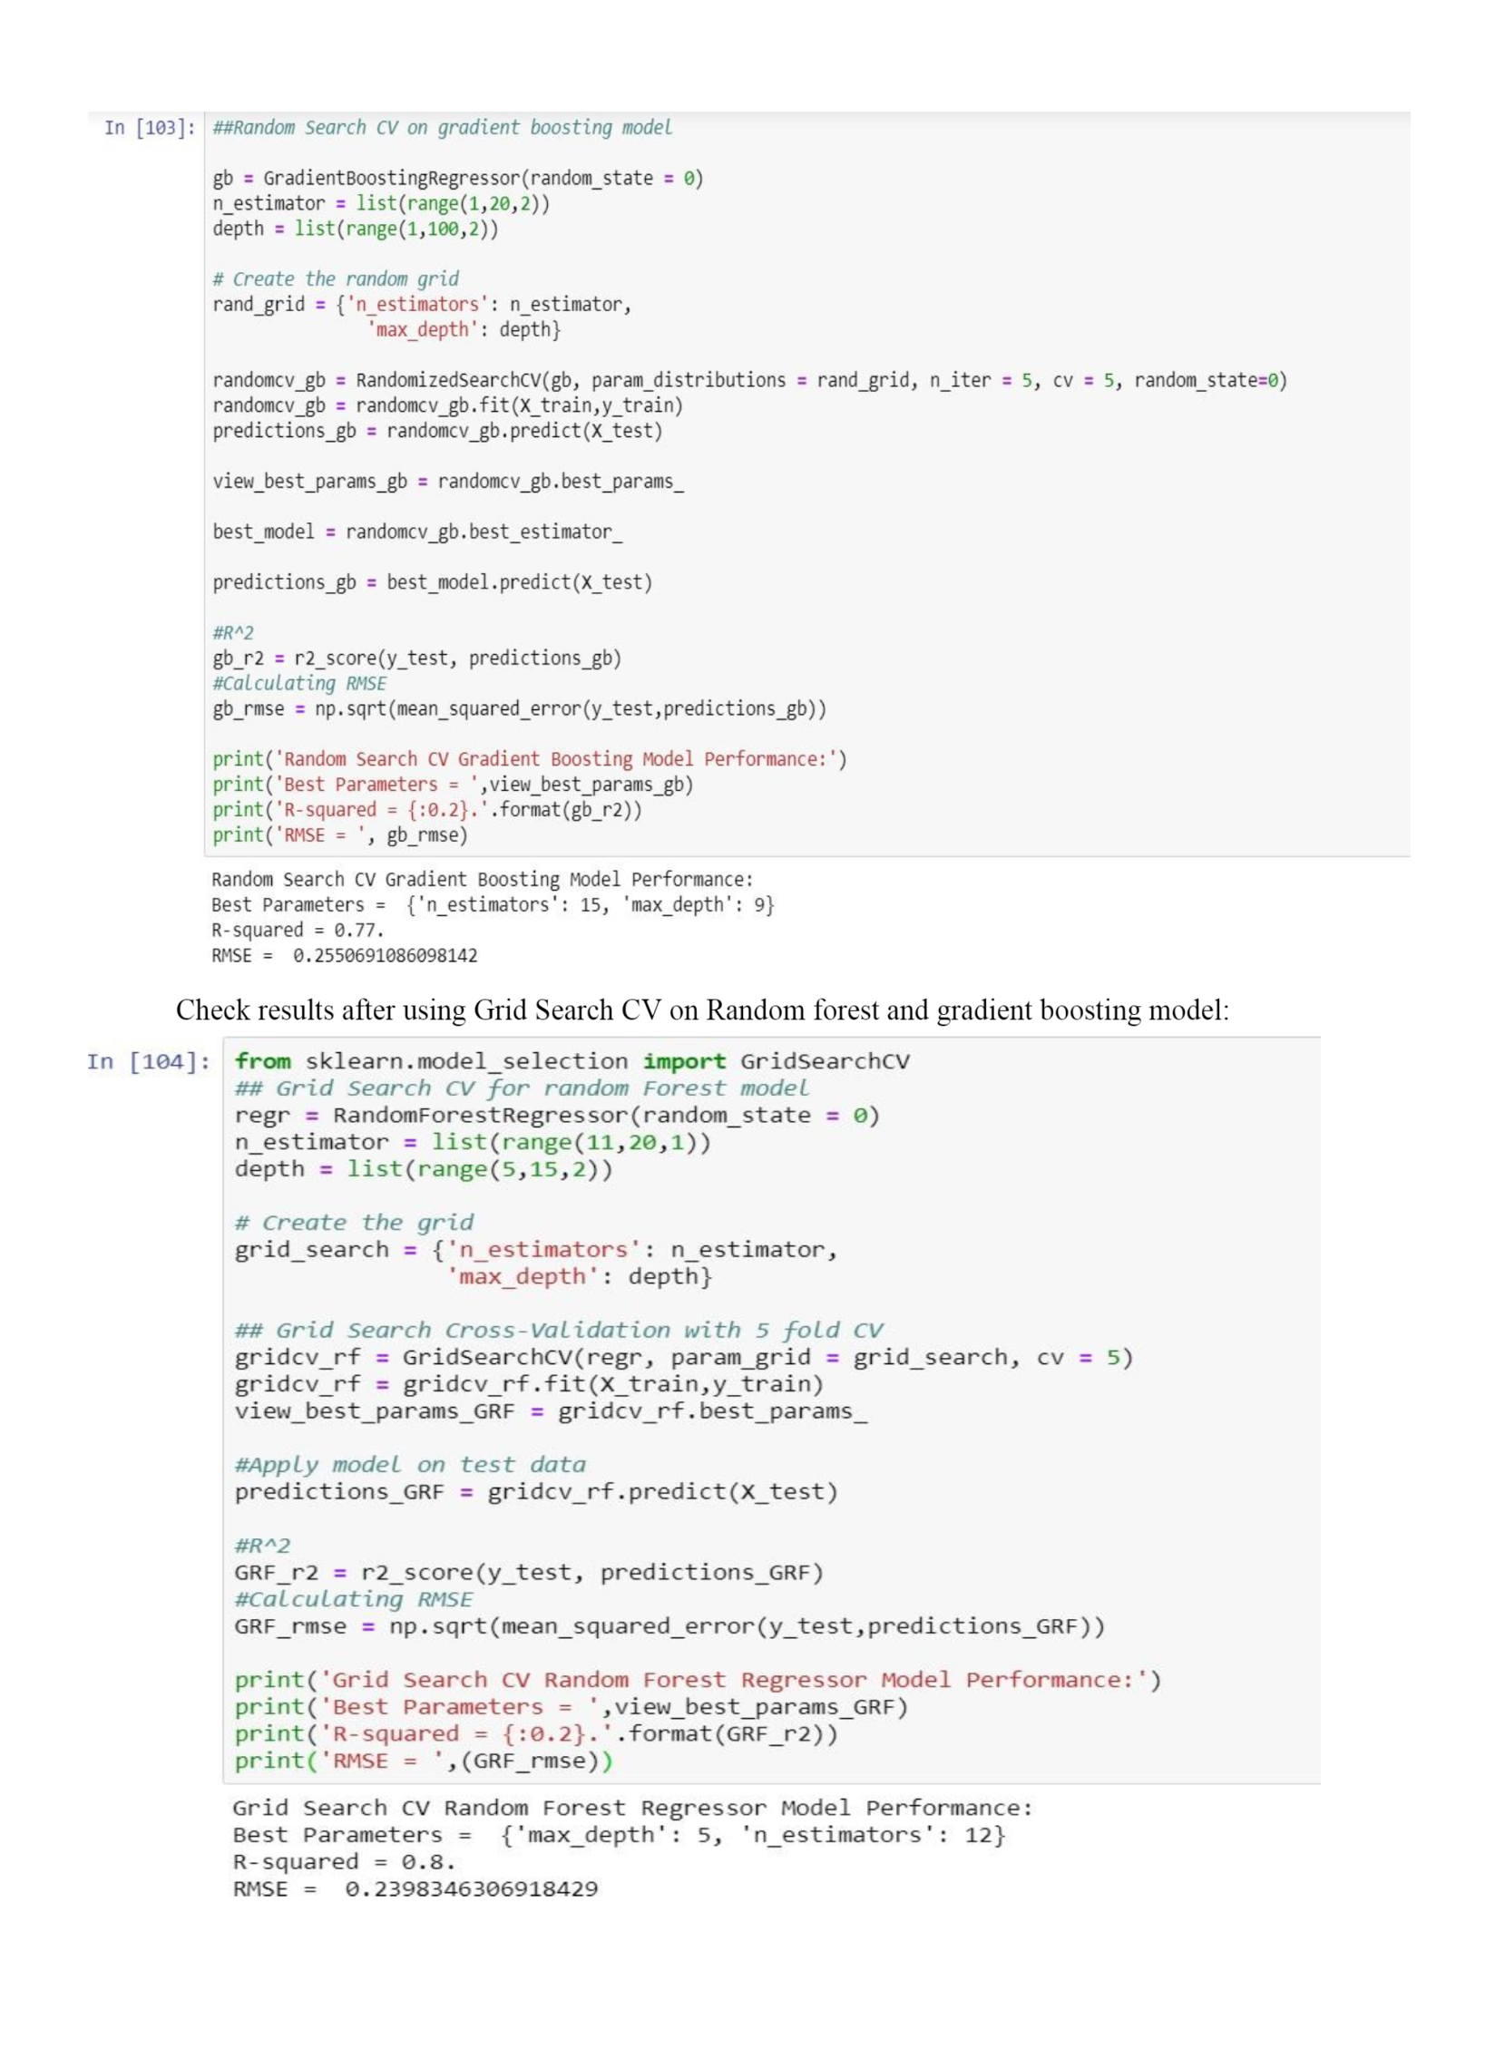

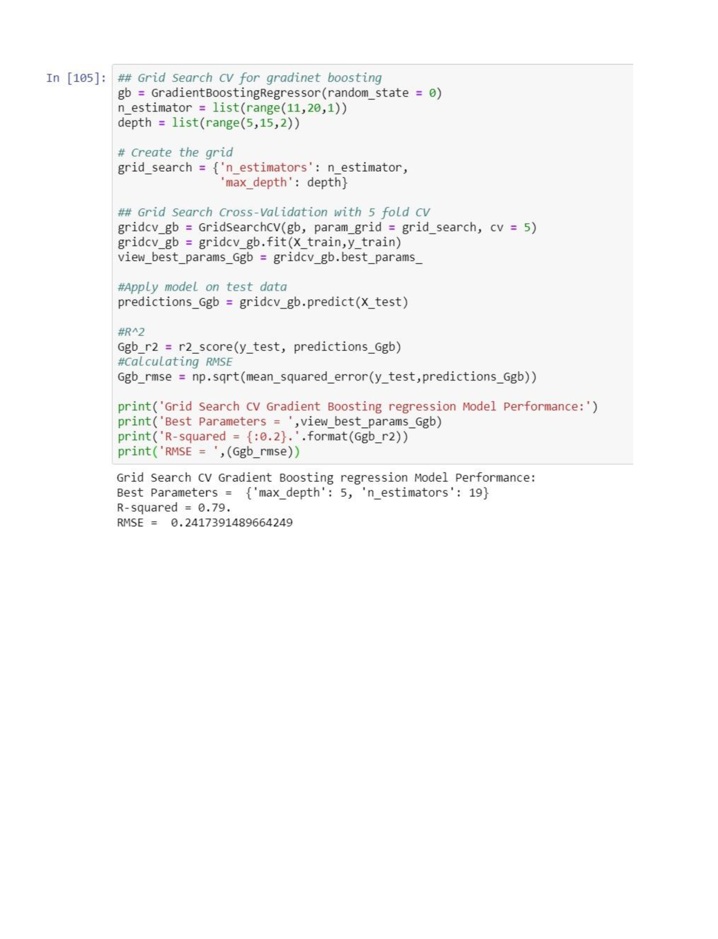

**Chapter 5**

**Conclusion**

**5.1 Model Evaluation**

The main concept of looking at what is called residuals or difference between our predictions f(x[I,]) and actual outcomes y[i].

In general, most data scientists use two methods to evaluate the performance of the model:

I. **RMSE (Root Mean Square Error**): is a frequently used measure of the difference between values predicted by a model and the values actually observed from the environment that is being modelled.

RMSE =

II. **R Squared(R^2):** is a statistical measure of how close the data are to the fitted regression line. It is also known as the coefficient of determination, or the coefficient of multiple determination for multiple regression. In other words, we can say it explains as to how much of the variance of the target variable is explained.

III. We have shown both train and test data results, the main reason behind showing both the results is to check whether our data is overfitted or not.

Below table shows the model results before applying hyper tuning:

|  |  |  |  |  |
| --- | --- | --- | --- | --- |
| **Model Name** | **RMSE** | | **R Squared** | |
| **Train** | **Test** | **Train** | **Test** |
| Linear Regression | 0.27 | 0.25 | 0.74 | 0.77 |
| Decision Tree | 0.30 | 0.28 | 0.70 | 0.70 |
| Random Forest model | 0.09 | 0.23 | 0.96 | 0.79 |
| Gradient Boosting | 0.22 | 0.22 | 0.82 | 0.81 |

Below table shows results post using hyper parameter tuning techniques:

|  |  |  |  |
| --- | --- | --- | --- |
| **Model Name** | **Parameter** | **RMSE (Test)** | **R Squared (Test)** |
| **Random Search CV** | Random Forest | 0.24 | 0.79 |
| Gradient Boosting | 0.25 | 0.77 |
| **Grid Search CV** | Random Forest | 0.23 | 0.80 |
| Gradient Boosting | 0.24 | 0.79 |

Above table shows the results after tuning the parameters of our two best suited models i.e. Random Forest and Gradient Boosting. For tuning the parameters, we have used Random Search CV and Grid Search CV under which we have given the range of n_estimators, depth and CV folds.

**5.2 Model Selection**

On the basis RMSE and R Squared results a good model should have least RMSE and max R Squared value. So, from above tables we can see:

• From the observation of all RMSE Value and R-Squared Value we have concluded that,

• Both the models- Gradient Boosting Default and Random Forest perform comparatively well while comparing their RMSE and R-Squared value.

• After this, I chose Random Forest CV and Grid Search CV to apply cross validation technique and see changes brought about by that.

• After applying tunings Random forest model shows best results compared to gradient boosting.

• So finally, we can say that Random forest model is the best method to make prediction for this project with highest explained variance of the target variables and lowest error chances with parameter tuning technique Grid Search CV.

**Finally, I used this method to predict the target variable for the test data file shared in the problem statement. Results that I found are attached with my submissions.**

**5.3 Some more visualization facts:**

**1. Number of passengers and fare**

We can see in below graph that single passengers are the most frequent travelers, and the highest fare also seems to come from cabs which carry just 1 passenger.

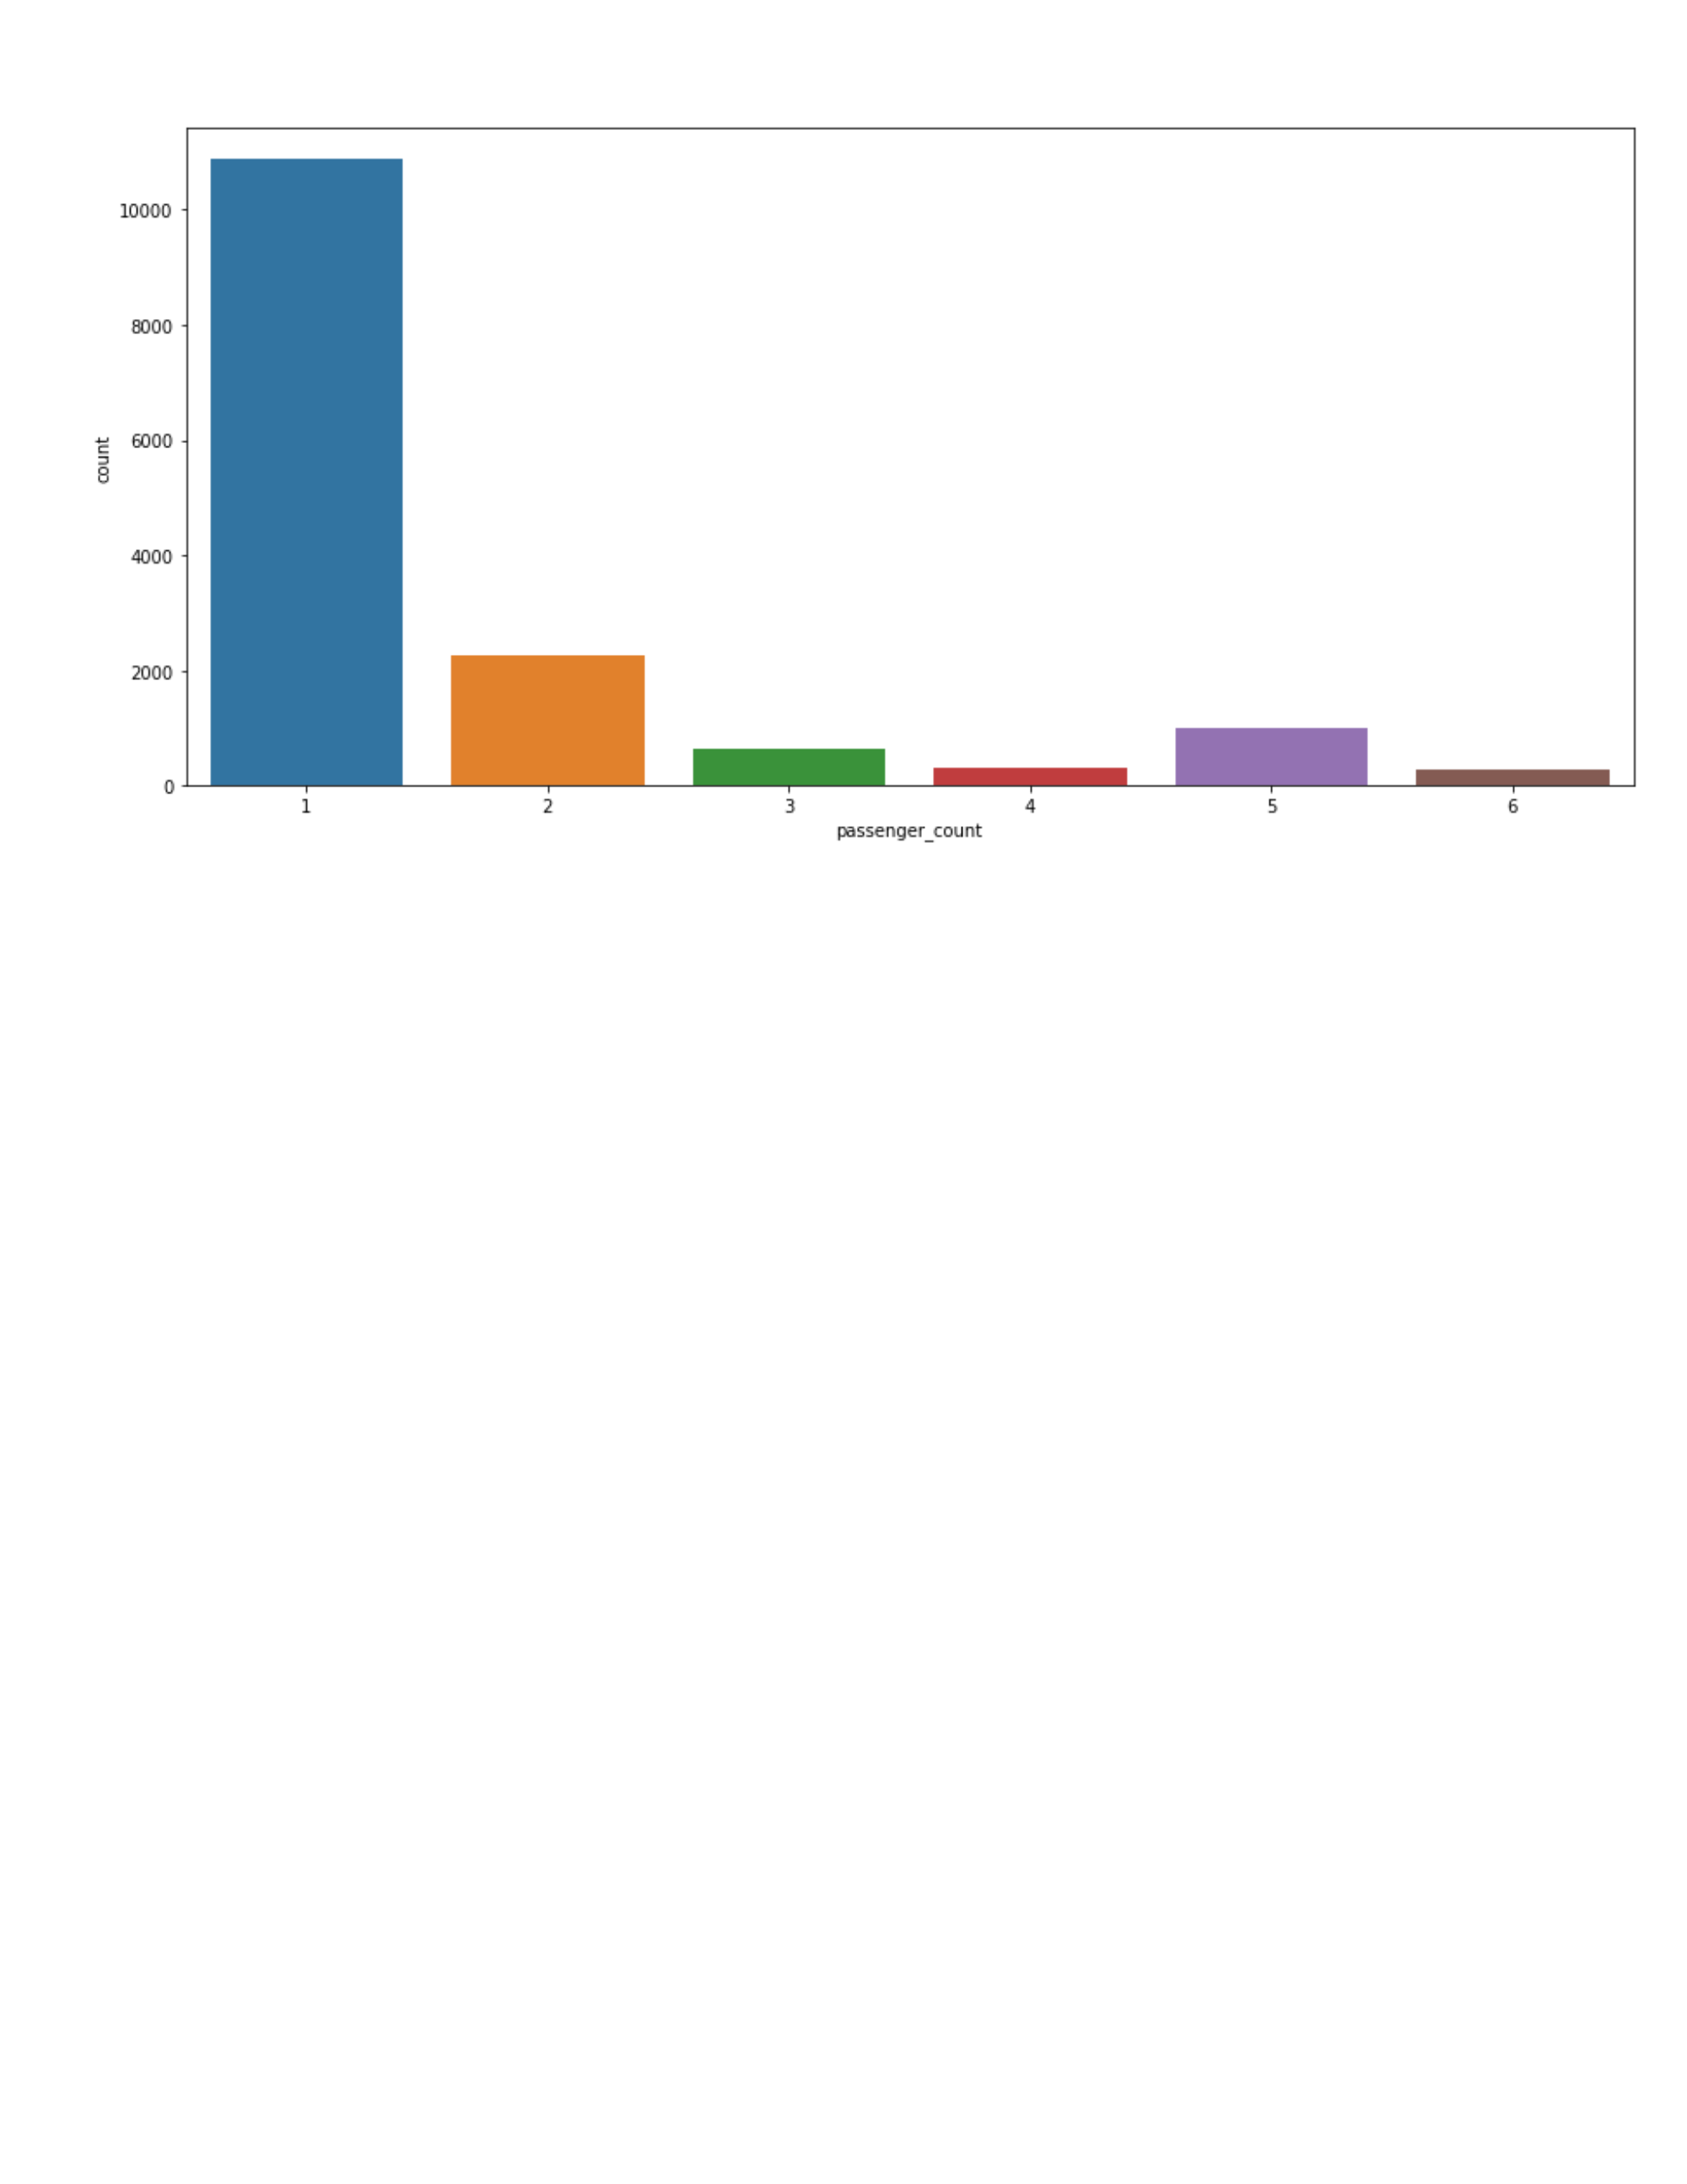

**2. Date of month and fares**

The fares throughout the month mostly seem uniform.

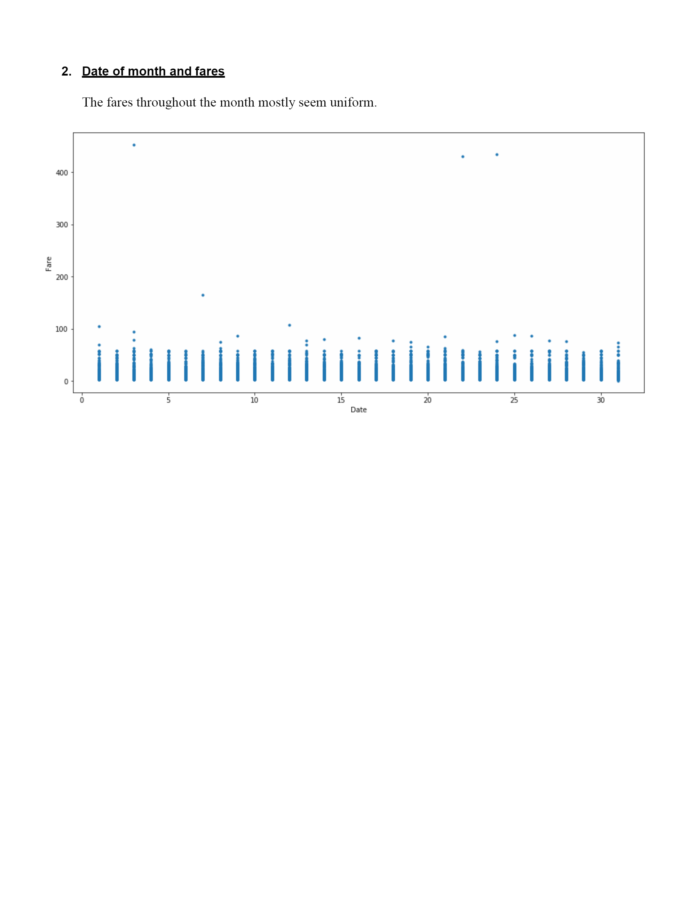

**3. Hours and Fares**

• During hours 6 PM to 11PM the frequency of cab boarding is very due to peak hours

• Fare prices during 2PM to 8PM is bit high compared to all other time might be due to high demands.

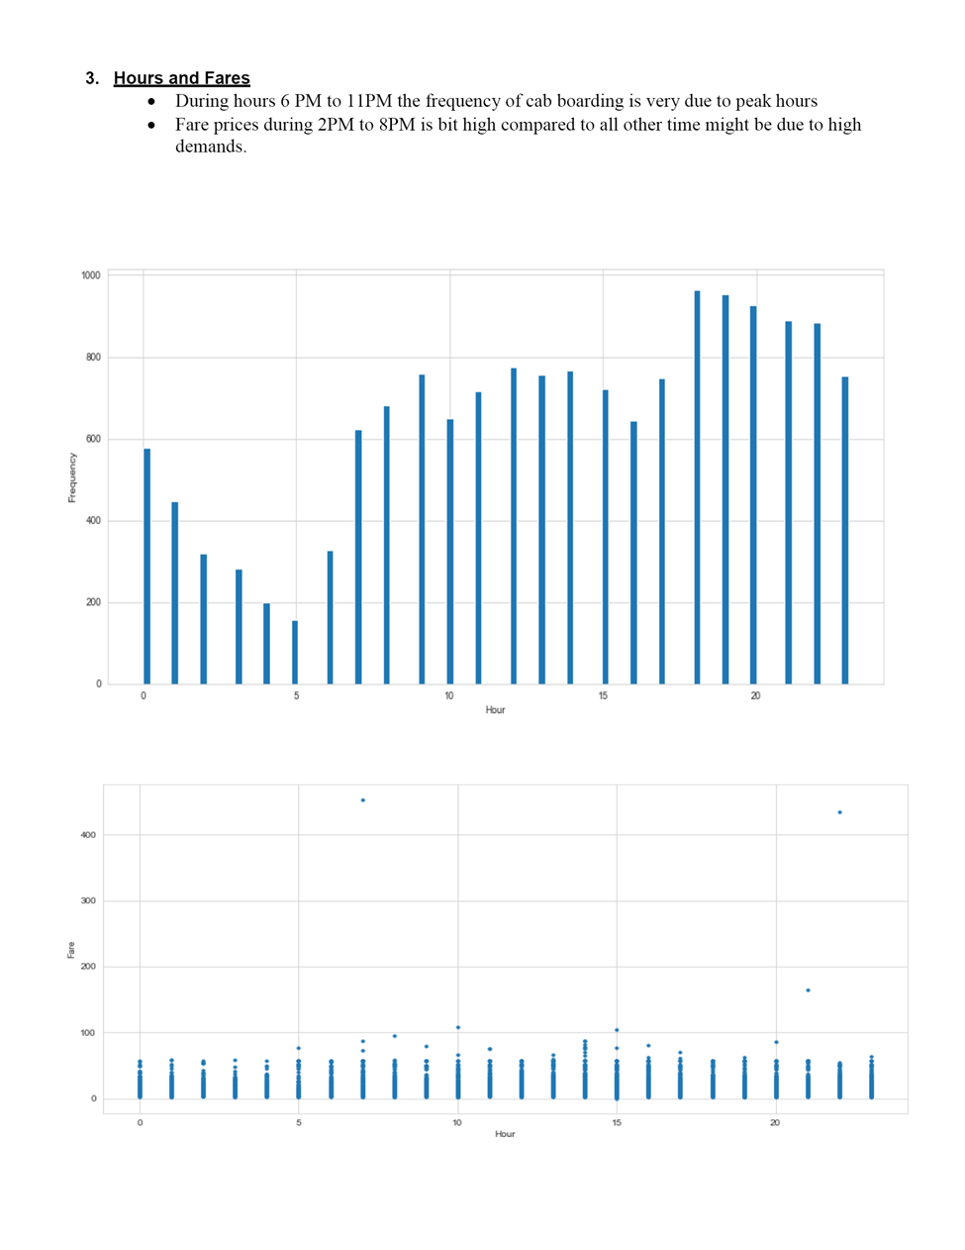

**4. Week Day and fare**

• Cab fare is high on Friday, Saturday and Monday, may be during weekend and first day of the working day they charge high fares because of high demands of cabs.

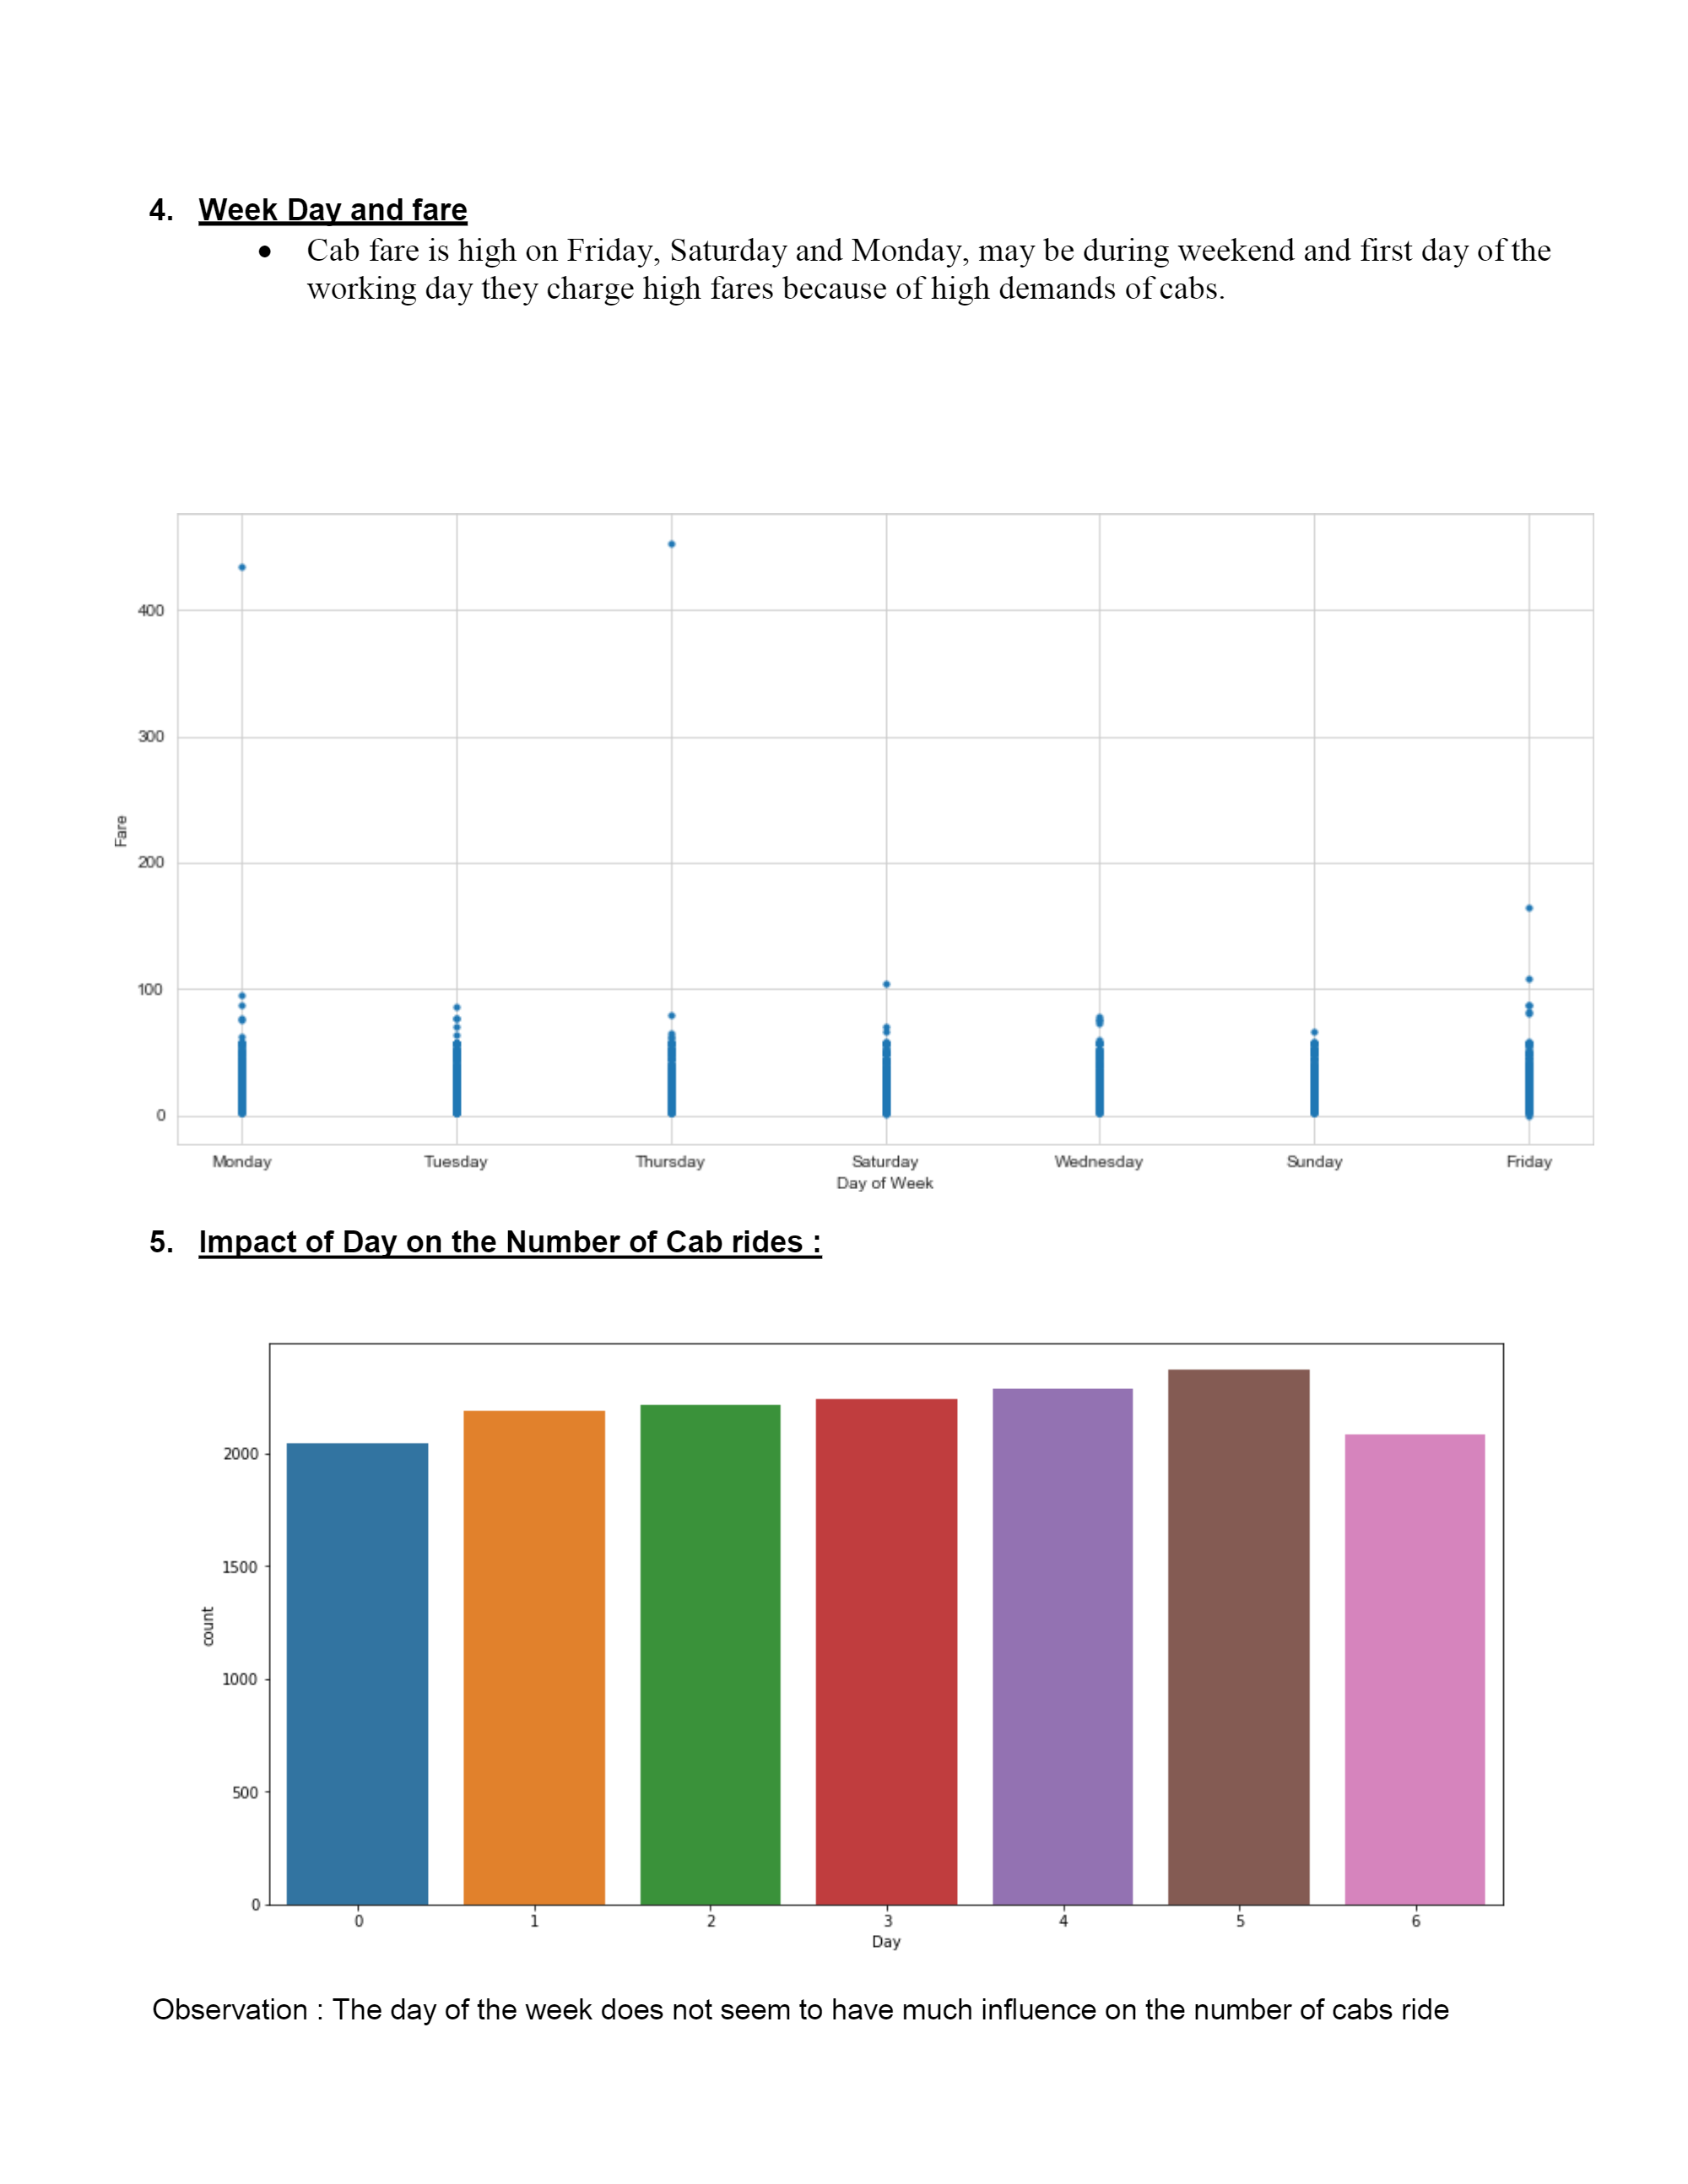

**5. Impact of Day on the Number of Cab rides :**

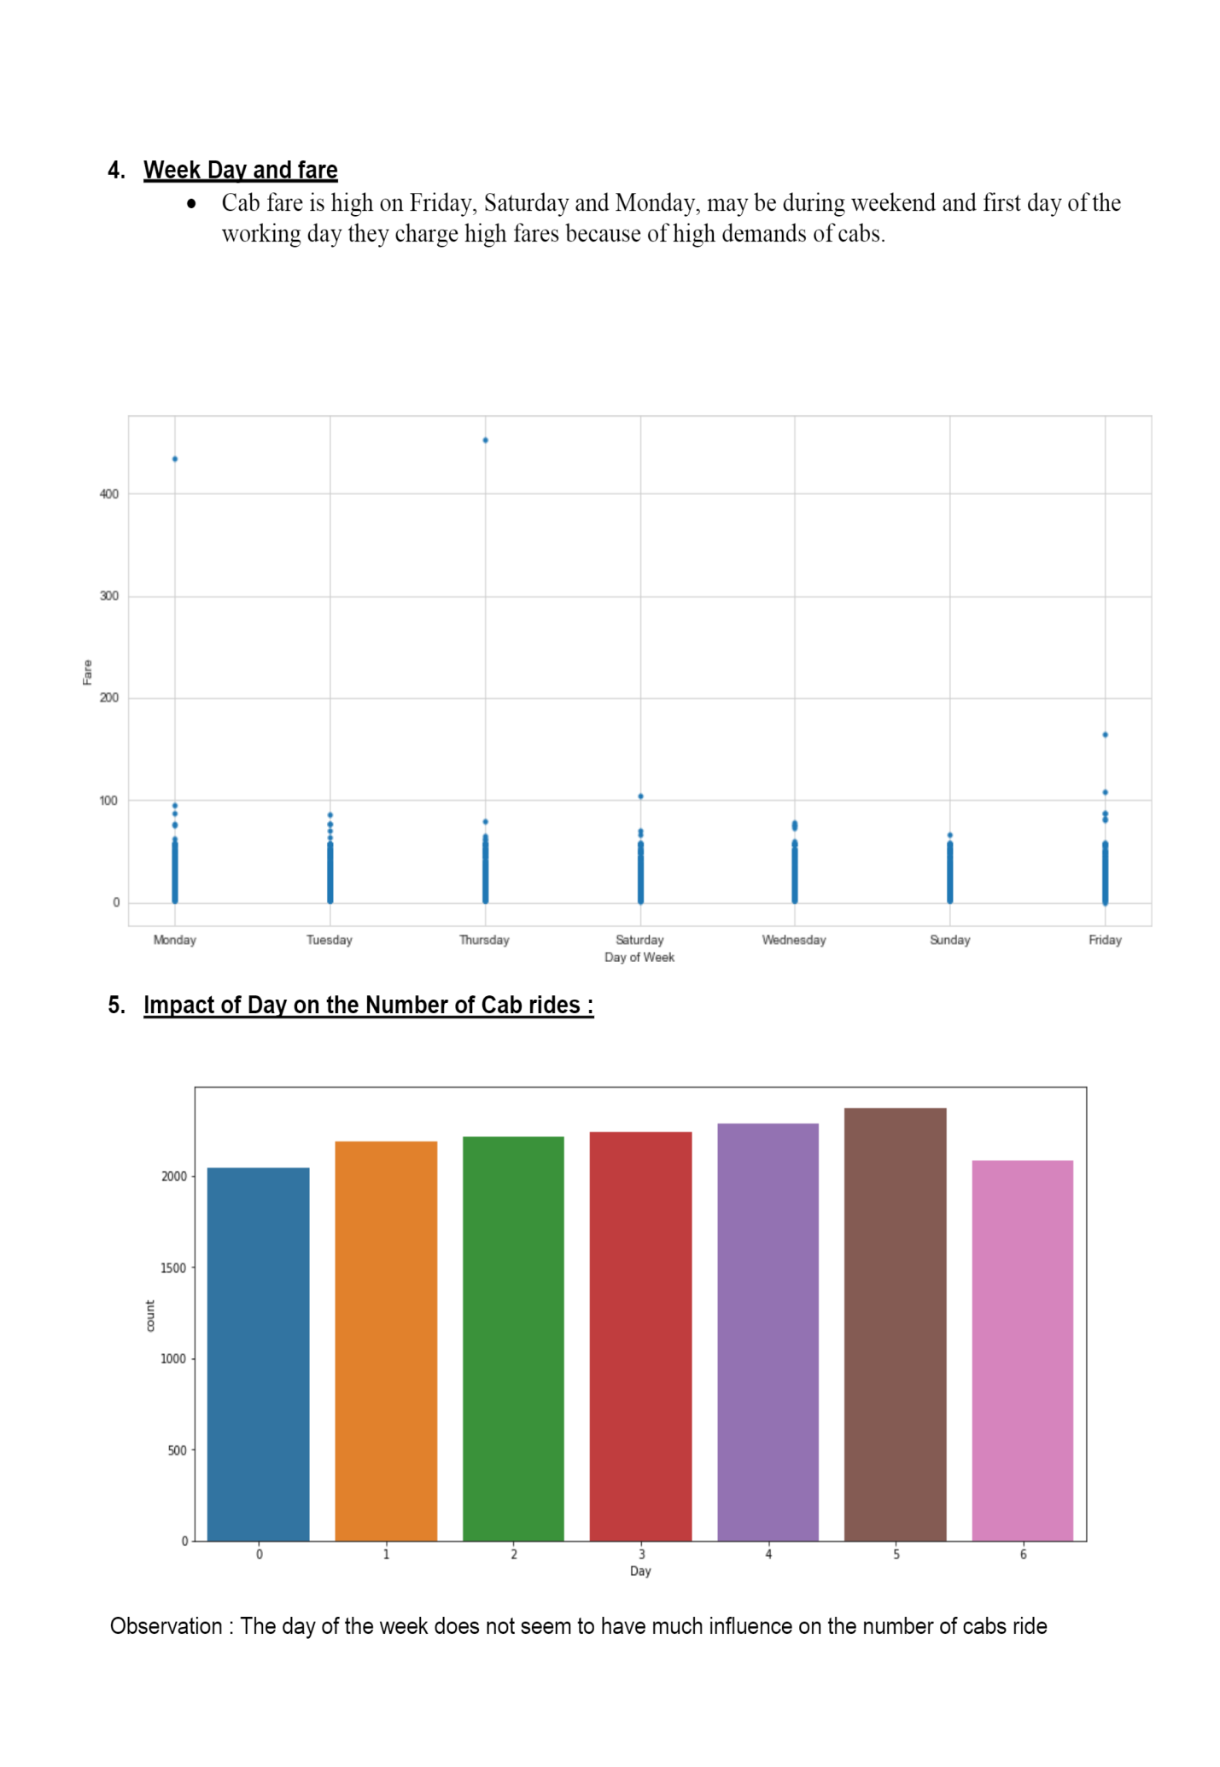**Observation** : The day of the week does not seem to have much influence on the number of cabs ride

**End of Report**

*References*

1. For Data Cleaning and Model Development - <https://edwisor.com/career-data-scientist>

2. For other code related queries - [https://www.analyticsvidhya.com/blog/2016/03/practical-guide-principal-component-analysis- python/](https://www.analyticsvidhya.com/blog/2016/03/practical-guide-principal-component-analysis-%20python/)

3. For Visualization – <https://www.udemy.com/python-for-data-science-and-machine-learning-bootcamp/>

4. <https://towardsdatascience.com/>

5. https://stackoverflow.com/

**Appendix**

R code:

rm(list = ls())

setwd("C:/Users/PRASHANT/Desktop/car fare prediction project")

getwd()

# #loading Libraries

x = c("ggplot2", "corrgram", "DMwR", "caret", "randomForest", "e1071","geosphere",

"DataCombine", "pROC", "doSNOW", "class", "readxl","ROSE","dplyr", "plyr", "reshape","xlsx",

"pbapply", "unbalanced", "dummies", "MASS" , "gbm" ,"Information", "rpart", "tidyr", "miscTools")

# #install.packages if not

lapply(x, install.packages)

# #load libraries

lapply(x, require, character.only = TRUE)

rm(x)

#Input Data Source

df = data.frame(read.csv('train_cab.csv'))

df2 = data.frame(read.csv('test.csv'))

###########################################################################

# EXPLORING DATA #

###########################################################################

#viewing the data

head(df)

########################################################################################## ######################

#structure of data or data types

str(df)

#Summary of data

summary(df)

#unique value of each count

apply(df, 2,function(x) length(table(x)))

df$pickup_datetime <- gsub('\\ UTC','',df$pickup_datetime)

#Splitting Date and time

df$Date <- as.Date(df$pickup_datetime)

df$Year <- substr(as.character(df$Date),1,4)

df$Month <- substr(as.character(df$Date),6,7)

df$Weekday <- weekdays(as.POSIXct(df$Date), abbreviate = F)

df$Date <- substr(as.character(df$Date),9,10)

df$Time <- substr(as.factor(df$pickup_datetime),12,13)

#Now we can drop the column pickup_datetime as we have different columns

df = subset(df, select = -c(pickup_datetime))

#########################################################################

# Checking Missing data #

#########################################################################

apply(df, 2, function(x) {sum(is.na(x))}) # in R, 1 = Row & 2 = Col

#Creating dataframe with missing values present in each variable

null_val = data.frame(apply(df,2,function(x){sum(is.na(x))}))

null_val$Columns = row.names(null_val)

names(null_val)[1] = "null_percentage"

#Calculating percentage missing value

null_val$null_percentage = (null_val$null_percentage/nrow(df)) * 100

# Sorting null_val in Descending order

null_val = null_val[order(-null_val$null_percentage),]

row.names(null_val) = NULL

# Reordering columns

null_val = null_val[,c(2,1)]

#viewing the % of missing data for all variales

null_val

#We have seen that null values are very less in our data set i.e. less than 1%.

#So we can delete the columns having missing values df <- DropNA(df)

#Verifying missing values after deletion

sum(is.na(df))

names(df)

# Convert degrees to radians- Our data is already in radians, so skipping this step

#deg2rad <- function(deg) return(deg*pi/180)

# Calculates the geodesic distance between two points specified by

# radian latitude/longitude using the Haversine formula

lat1 = df['pickup_latitude']

lat2 = df['dropoff_latitude']

long1 = df['pickup_longitude']

long2 = df['dropoff_longitude']

##### Function to calculate distance ######

gcd_hf <- function(long1, lat1, long2, lat2) {

R <- 6371.145 # Earth mean radius [km]

delta.long <- (long2 - long1) delta.lat <- (lat2 - lat1)

a <- sin(delta.lat/2)^2 + cos(lat1) * cos(lat2) * sin(delta.long/2)^2

c <- 2 * atan2(sqrt(a),sqrt(1-a))

d = R * c

return(d) # Distance in km

}

#Running the function for all rows in dataframe

for (i in 1:nrow(df))

{

df$distance[i]= gcd_hf(df$pickup_longitude[i], df$pickup_latitude[i], df$dropoff_longitude[i],

df$dropoff_latitude[i])

}

#Now we can drop the columns for latitude/longitude as we have new column- Distance

df = subset(df, select = -c(pickup_latitude,dropoff_latitude,pickup_longitude,dropoff_longitude))

########################################################################################## ##########

########################################################################################## ##########

#We have seen that fare_amount has negative values which should be removed

df$fare_amount[df$fare_amount<=0] <- NA

df$fare_amount[df$fare_amount>500] <- NA

sum(is.na(df))

#So we can delete the columns having missing values

df <- DropNA(df)

#Verifying missing values after deletion

sum(is.na(df))

summary(df)

###removing passangers count more than 6

df$passenger_count[df$passenger_count<1] <- NA

df$passenger_count[df$passenger_count>6] <- NA

sum(is.na(df))

df <- DropNA(df)

sum(is.na(df))

summary(df)

###removing outliers in distance

df$distance[df$distance <= 0] <- NA

df$distance[df$distance > 500] <- NA

sum(is.na(df))

df <- DropNA(df)

sum(is.na(df))

summary(df)

# From the above EDA and problem statement categorizing data in 2 categories "continuous" and "categorical"

#Fare_amount being our target variable is excluded from the list.

cont = c( 'distance')

cata = c('Weekday', 'Month', 'Year' , 'Time', 'Date' , 'passenger_count')

#########################################################################

# Visualizing the data #

#########################################################################

#library(ggplot2)

#Plot fare amount Vs. the days of the week.

ggplot(data = df, aes(x = reorder(Weekday,-fare_amount), y = fare_amount))+

geom_bar(stat = "identity")+

labs(title = "Fare Amount Vs. days", x = "Days of the week", y = "Fare")+

theme(plot.title = element_text(hjust = 0.5, face = "bold"))+

theme(axis.text.x = element_text( color="black", size=6, angle=45))

#Plot Fare amount Vs. months

ggplot(df,aes(x = reorder(Month,-fare_amount), y = fare_amount))+

geom_bar(stat = "identity")+

#ylim = c(0,1000) +

labs(title = "Fare Amount Vs. Month", x = "Month", y = "Fare")+

theme(axis.text.x = element_text( color="#993333", size=8))

################################################################

# Outlier Analysis #

################################################################

#We have done manual updation so we will skip this step

################################################################

# Feature Selection #

################################################################

## Dimension Reduction

#We have already excluded the below columns that were redundant:

#pickup_datetime,

#pickup_latitude,

#dropoff_latitude,

#pickup_longitude,

#dropoff_longitude

#pickup_datetime

#We will remove Time column also as it is not required

##df = subset(df, select = -c(Time))

################################################################

# Feature Scaling #

################################################################

#We will go for Normalization.

#Viewing data before Normalization.

head(df)

signedlog10 = function(x) {

ifelse(abs(x) <= 1, 0, sign(x)*log10(abs(x)))

}

df$fare_amount = signedlog10(df$fare_amount)

df$distance = signedlog10(df$distance)

##checking distribution

hist(df$fare_amount)

hist(df$distance)

#Normalization

for(i in cont)

{

print(i)

df[,i] = (df[,i] - min(df[,i]))/(max(df[,i])-min(df[,i]))

}

hist(df$distance)

#Viewing data after Normalization.

head(df)

#Creating dummy variables for categorical variables

library(mlr)

df1 = dummy.data.frame(df, cata)

#Viewing data after adding dummies

head(df1)

#df1 = df

################################################################

# Sampling of Data #

################################################################

# #Divide data into trainset and testset using stratified sampling method

#install.packages('caret')

library(caret)

set.seed(101)

split_index = createDataPartition(df1$fare_amount, p = 0.7, list = FALSE)

trainset = df1[split_index,]

testset = df1[-split_index,]

#Checking df Set Target Class

table(trainset$fare_amount)

####FUNCTION to calculate MAPE####

MAPE = function(y, yhat){

mean(abs((y - yhat)/y))*100

}

########################################################################################## ##################################################################

## Basic approach for ML - Models

##

## We will first get a basic idea of how different models perform on our preprocesed data and then select the best model and make it ##

## more efficient for our Dataset

##

########################################################################################## ##################################################################

#------------------------------------------Decision tree-------------------------------------------#

#Develop Model on training data

fit_DT = rpart(fare_amount ~., data = trainset, method = "anova")

#Variable importance

fit_DT$variable.importance

# distance Time05 passenger_count

## 725793.64246 431.82787 13.85704

#Lets predict for test data

pred_DT_test = predict(fit_DT, testset)

# For test data

print(postResample(pred = pred_DT_test, obs = testset$fare_amount))

#Compute R^2

dt_r2 = rSquared(testset$fare_amount, testset$fare_amount - pred_DT_test)

print(dt_r2)

#Compute MSE

dt_mse = mean((testset$fare_amount - pred_DT_test)^2)

print(dt_mse)

#Compute MAPE

dt_mape = MAPE(testset$fare_amount, pred_DT_test)

print(dt_mape)

# RMSE Rsquared MAE

# 0.12 0.59 0.01

#------------------------------------------Linear Regression-------------------------------------------#

#Develop Model on training data

fit_LR = lm(fare_amount ~ ., data = trainset)

#Lets predict for test data

pred_LR_test = predict(fit_LR, testset)

# For test data

print(postResample(pred = pred_LR_test, obs = testset$fare_amount))

#Compute R^2

lr_r2 = rSquared(testset$fare_amount, testset$fare_amount - pred_LR_test)

print(lr_r2)

#Compute MSE

lr_mse = mean((testset$fare_amount - pred_LR_test)^2)

print(lr_mse)

#Compute MAPE

lr_mape = MAPE(testset$fare_amount, pred_LR_test)

print(lr_mape)

##RMSE Rsquared MAE

##0.13 0.53 0.01

#-----------------------------------------Random Forest----------------------------------------------#

#Develop Model on training data

fit_RF = randomForest(fare_amount~., data = trainset)

#Lets predict for test data

pred_RF_test = predict(fit_RF, testset)

# For test data

print(postResample(pred = pred_RF_test, obs = testset$fare_amount))

#Compute R^2

rf_r2 = rSquared(testset$fare_amount, testset$fare_amount - pred_RF_test)

print(rf_r2)

#Compute MSE

rf_mse = mean((testset$fare_amount - pred_RF_test)^2)

print(rf_mse)

#Compute MAPE

rf_mape = MAPE(testset$fare_amount, pred_RF_test)

print(rf_mape)

# RMSE Rsquared MAE

#R2

#MSE

#MAPE

#

#--------------------------------------------XGBoost-------------------------------------------#

### for xgboost it is required to make date variable as factor.

trainset$Date <- as.factor(trainset$Date)

#Develop Model on training data

fit_XGB = gbm(fare_amount~., data = trainset, n.trees = 500, interaction.depth = 2)

#Lets predict for test data

pred_XGB_test = predict(fit_XGB, testset, n.trees = 500)

# For test data

print(postResample(pred = pred_XGB_test, obs = testset$fare_amount))

#Compute R^2

xgb_r2 = rSquared(testset$fare_amount, testset$fare_amount - pred_XGB_test)

print(xgb_r2)

#Compute MSE

xgb_mse = mean((testset$fare_amount - pred_XGB_test)^2)

print(xgb_mse)

#Compute MAPE

xgb_mape = MAPE(testset$fare_amount, pred_XGB_test)

print(xgb_mape)

# RMSE Rsquared MAE

#

#R2

#

#MSE

#

#MAPE

#

#################-------------------------------Viewing summary of all models------------------------------ ###############

# Create variables

MSE <- c(dt_mse, lr_mse, rf_mse, xgb_mse)

r2 <- c(dt_r2, lr_r2, rf_r2, xgb_r2)

MAPE <- c(dt_mape, lr_mape, rf_mape, xgb_mape)

# Join the variables to create a data frame

results <- data.frame(MSE,r2,MAPE)

results

# MSE r2 MAPE

#1

#2

#3

#4

########################################################################################

# Saving output to file #

########################################################################################

#swrite.csv(submit,file = 'C:/Users/Click/Desktop/Bike rental/Finalcount_R.csv',row.names = F)

#rm(list = ls())

**R PROGRAMMING**

#remove all program/objects from RAM

rm(list=ls())

#set wirking directory

setwd("D:/Car Fare Prediction/")

#checking current working directory

getwd()

#before starting this project with dataset. Initially I open test & train_cab files in excel and just look the data available

# starting the project I need to load some libraries to deal with this data

install.packages(c("lattice", "dplyr", "plyr", "ggplot2", "corrgram" ))

#load train & test dataset for analysis

train = read.csv("train_cab.csv", header = T)

test = read.csv("test.csv", header =T)

#understanding the data by getting number of observations and variables

dim(train)

dim(test)

#in R studio I see that, train data has 16067 observations and 7 variables

# whereas test data has 9914 observations and 6 variables

#getting structure of both train and test dataset

str(train)

str(test)

#cheking few data in train dataset

head(train,10)

#cheking few data in test dataset

head(test, 10)

#After checking both the dataset,

#I found that there is 6 indepedent variable and 1 dependent variable in train dataset.

#So I need to analyse the train dataset properly and develope the model

#and that model will be implemented on test dataset.

#print concise summary of train dataset

summary(train)

#print concise summary of test dataset

summary(test)

#Seeing the both dataset summary,

#I conclude that, there are some missing values in train dataset

#i.e. fare_amount and passenger_count and No missing data in test dataset.

#for that reason I need to do the Missing Value Annalysis here

#before missing values I need to convert factor data into numeric to perform missing value operations

#but in fare_amount I found that there are some missing values but these are not showing as NA

#for that I convert fare_amount into vector then numeric

train$fare_amount = as.vector(train$fare_amount)

#convert fare_amount from vector to numeric

train$fare_amount = as.numeric(train$fare_amount)

#convert pickup_datetime

train$pickup_datetime = as.POSIXct(train$pickup_datetime, tz = "UTC",format ="%Y-%m-%d %H:%M:%OS")

#############################################################################################

#Missing Value Analysis

##############################################################################################

#checking numeber of missing values in train dataset

sum(is.na(train)) #found 81 missing values in train dataset

#checking variables with missing values count

sapply(train, function(x) sum(is.na(x)))

#there are 25 missing values in fare_amount, 1 missing value in pickup_date

#and 55 missing values in passenger_count

#checking number of missing values in test dataset

sum(is.na(test)) #no missing value in test dataset

#create data frame with missing percentage

missing_val = data.frame(apply(train,2, function(x){sum(is.na(x))}))

#convert row names into columns

missing_val$columns = row.names(missing_val)

row.names(missing_val) = NULL

#rename the variable names

names(missing_val)[1] = "Missing_Percentage"

#calculate percentage

missing_val$Missing_Percentage = (missing_val$Missing_Percentage / (nrow(train)))*100

#after missing percentage calculations

#there is only 0.15% and 0.34% missing values present in fare_amount and passenger_count resp.

#dropping the missing values from dataset

train = na.omit(train)

#############################################################################################

# Outlier Analysis

#############################################################################################

#checking if any negative & zero fare_amount present in dataset

sum(train$fare_amount<=0)

#4 fare_amount has negative & zero value, which wont make any sense. Remove this fields

train = subset(train, train$fare_amount>0) #4 observations dropped

#summary of fare_amount

summary(train$fare_amount)

#this shows that there is fare_amount Min = 0.01 but Max = 54343 which is not possible for Car Fare

#to understand the highest values better I arrange this train dataset in decending order

train = train[order(-train$fare_amount),]

#After Checking highest fare_amount, fount that there 3 values which are highest and not possible

#in fare_amount i.e. fare-amount = 54343.00, fare_amount = 4343.0000 and fare_amount = 0.01.

#I need to drop these values from the train dataset

train = subset(train,train$fare_amount<4000) #2 observations dropped

train = subset(train, train$fare_amount!=0.01) #1 observation drop

#now there is highest fare_amount is 453.00

#and lowest fare_amount is 1.14

#Now deal with passenger_count

summary(train$passenger_count)

#Checking the passenger_count summary.

#I shock to see the max value is 5345. Lol which is not possible even in train.

#Lets check the list of passenger_count in descending order. It will clear the picture

train = train[order(-train$passenger_count),]

#After Checking, passenger_count ranges from 35 to 5345.

#As I am analyzing dataset of Cabs, then This is not possible.

#Also there are some observations with passenger_count = 0 & 0.12

#So these values are stictly outliers. I need to drop them.

#for cab fare prediction, I am consider the Max Number of passengers are 6.

#Which make sense if cab is "SUV"

#Now drop the observations which has passenger_count value greater than or equal to 6

train = subset(train, train$passenger_count<=6) #19 observations dropped

train = subset(train, train$passenger_count!=0) #57 observations dropped

train = subset(train, train$passenger_count!=0.12) #1 observarion dropped

train = train[order(train$passenger_count),]

#lets check these thing with test dataset

summary(test)

#our test dataset is free from passenger_count outliers

#now its time to deal with the pickup longitude and latitude

##let us explore the pickup latitude and longitudes

summary(train$pickup_latitude)

summary(train$pickup_longitude)

#Exploring the pickup longitute and latidude it is difficult to know the location

#for that reason I just Google these things.

#Found one useful website to identify the location

#https://www.latlong.net/Show-Latitude-Longitude.html

#The above website gives the Actual Location based on longitude and latitude

#after doing so randon check on website and using describe

#function, I conclude that the pilot project run in New York City of United States.

#Googleing gives the New York City Longitude and Latitude i.e.

#New York City Latitude and longitude coordinates are: 40.730610, -73.935242.

#after using describe function on train dataset pickup_longitude and pickup_latitude

#are near to the actual cordinates of New York city.

#For that I am considering the longitude and latitude ranges for our train dataset

#Latitude ranges from 39 to 43

#Longitude ranges from -72 to -76

#from that I can say there are clearly shows some outliers. Let's drop them

train = subset(train, train$pickup_latitude>39) #318 observations dropped

train = subset(train, train$pickup_latitude<43) #1 observations dropped

#similar operation for pickup longitude

train = subset(train, train$pickup_longitude < -72) #No observations dropped

train = subset(train, train$pickup_longitude>-76) #No observations dropped

#Now dealing with the dropoff_lattitude and dropoff_longitude

#similar operation for dropoff latitude and longitude

summary(train$dropoff_latitude)

summary(train$dropoff_longitude)

#dropping outliers in dropoff_longitude

train = subset(train, train$dropoff_latitude>39) #10 observations dropped

train = subset(train, train$dropoff_latitude<43) #No observation dropped

#similar operation for dropoff_longitude

train = subset(train, train$dropoff_longitude < -72) #03 observations dropped

train = subset(train, train$dropoff_longitude>-76) #No observations dropped

#############################################################################################

#feature selection

#############################################################################################

#Correlation Analysis: Here I am generating correlation matrix to understand

#how the each variable related with each other.

#In that I am plotting correlation matrix and

#generate plot for better understanding

library(corrgram)

#Correlation plot

corrgram(train, order = F, upper.panel = panel.pie, text.panel = panel.txt, main = "Correlation Plot")

#The above correlation analysis shows that,

#each variable in dataset is indepedent and not correlated with each other.

#So, each variable or feature play an important role to predict the fare_amount

###############################################################################################

#Data types conversions

###############################################################################################

#Check the data types of each columns in train and test dataset before further analysis

#check data types of train dataset

sapply(train, class)

#check data types of test dataset

sapply(test, class)

#pickup_datetime seem to be datetime column which are in factor format.

#similar way convert datetime in test dataset

test$pickup_datetime = as.POSIXct(test$pickup_datetime, tz = "UTC",format ="%Y-%m-%d %H:%M:%OS")

#in test dataset passenger_count variables in interger convert it in numeric format

test$passenger_count = as.numeric(test$passenger_count)

################################################################################################

# Exploratory Data Analysis

#list assumptions I Made

#Does the passenger_count (Number of Passengers) affect the fare_amount (fare)?

#Does the pickup_datetime (Pickup Date & Time) affect the fare_amount (fare)?

#Does the day of the week affect the fare_amount (fare)?

#Does the distance travelled affect the fare_amount (fare)?

################################################################################################

#First, Let's split the datetime field pickup_datetime to the following:

#year

#month

#date

#hour

#day of the week

#after this conversion, I will calculate the day of the week and

#come to our conclusion about how the pickup_location affect the fare_amount

train$Year = as.numeric(format(train$pickup_datetime, format = "%Y"))

train$Month = as.numeric(format(train$pickup_datetime, format = "%m"))

train$Date = as.numeric(format(train$pickup_datetime, format = "%d"))

#Monday = 1 Tuesday =2 , ....... Sunday =7

train$Day_of_week = as.numeric(strftime(train$pickup_datetime, format = "%u"))

train$Hour = as.numeric(format(train$pickup_datetime, format = "%H"))

#simiarly I am implementing this code for test data

test$Year = as.numeric(format(test$pickup_datetime, format = "%Y"))

test$Month = as.numeric(format(test$pickup_datetime, format = "%m"))

test$Date = as.numeric(format(test$pickup_datetime, format = "%d"))

#Monday = 1 Tuesday =2 , ....... Sunday =7

test$Day_of_week = as.numeric(strftime(test$pickup_datetime, format = "%u"))

test$Hour = as.numeric(format(test$pickup_datetime, format = "%H"))

#again check the datatypes of train & test dataset

sapply(train, class)

sapply(test, class)

#################################################################################################

#Distance calculations

#################################################################################################

#Now the most important, need to calculate the

#distance travelled by cab from the pickup latutude & longitude and dropoff latutude & longitude.

#To know how to calulate the distance from give data, I need to find formula.

#After Googleing, I found formula, named as Haversine Formula.

#Also creating a new filed 'distance' to fetch the distance between pickup and drop location

#We can calulate the distance in a sphere when latitudes and longitudes are given

#by Haversine formula

#haversine(??) = sin²(??/2)

#Eventually, the formual boils down to the following where ?? is latitude, ?? is longitude, R is earth's radius (mean radius = 6,371km) to include latitude and longitude coordinates (A and B in this case).

#a = sin²((??B - ??A)/2) + cos ??A . cos ??B . sin²((??B - ??A)/2)

#c = 2 * atan2( ???a, ???(1???a) )

#d = R ??? c

#d = Haversine distance

#R have packages geosphere has built in function Haversine formula to calculate Distance

install.packages("geosphere")

library(geosphere)

#Haversine Formula in train dataset

train$Distance = as.numeric(distHaversine(cbind(train$pickup_longitude, train$pickup_latitude), cbind(train$dropoff_longitude, train$dropoff_latitud), r = 6371))

#distance formula on test dataset

test$Distance = as.numeric(distHaversine(cbind(test$pickup_longitude, test$pickup_latitude), cbind(test$dropoff_longitude, test$dropoff_latitud), r = 6371))

#Here I also varify the actual distance I get through this formula and

#distance provided by website: https://www.geodatasource.com/distance-calculator

#based on longitude and latitude.

#From this I conclude that I am on right track

#Now lets clarify assumptions one by one that I made earlier:

###########################################################################################

#Does the passenger_count (Number of Passengers) affect the fare_amount (fare)?

###########################################################################################

library(ggplot2)

#plot passenger_count vs frequency,

ggplot(train, aes_string(x= train$passenger_count))+

geom_histogram(fill = "cornsilk", colour = "black", binwidth = 1)+theme_bw()+

xlab("Number of Passengers") + ylab("Frequency")

#plot passenger_count vs fare_amount

plot(x = train$passenger_count,y = train$fare_amount,

xlab = "Number of Passengers",

ylab = "Fare",

main = "passenger_count vs fare")

### from above two graphs,

#I see that single passenger is most frequent travellers,

#and highest fare also seems to come from cabs which carry just the 1 passenger.

##############################################################################################

#Does the pickup_datetime (Pickup Date & Time) affect the fare_amount (fare)?

##############################################################################################

#does the pickupdate of month affect the fare_amount

plot(x = train$Date,y = train$fare_amount,

xlab = "Date",

ylab = "Fare",

main = "Date vs Fare")

#From the above graph, the fare_amount throughout the month is seem to be uniform,

#with maximum fare received on the 3rd

#does pickuptime of the day affect the fare_amount?

ggplot(train, aes_string(x= train$Hour))+

geom_histogram(fill = "cornsilk", colour = "black", binwidth = 1)+theme_bw()+

xlab("Hour of the day") + ylab("Frequency")

#As the above graph shows, The time of the day plays an important role.

#The frequency of cab rides seem to be lowest at 5AM and the highest at 6PM.

plot(x = train$Hour,y = train$fare_amount,

xlab = "Hour of the day",

ylab = "Fare",

main = "Hour vs Fare")

#The fares, seem to be the high between 5AM to 10AM and 1PM to 4PM.

#Maybe people who leave early to avoid traffic and cover large distance

################################################################################################

#Does the day of the week affect the fare_amount (fare)?

################################################################################################

ggplot(train, aes_string(x= train$Day_of_week))+

geom_histogram(fill = "cornsilk", colour = "black", binwidth = 1)+theme_bw()+

xlab("Day of Week") + ylab("Frequency")

#The day of the week doesn't seem to have that much effect on number of cab rides

plot(x = train$Day_of_week,y = train$fare_amount,

xlab = "Day of Week",

ylab = "Fare",

main = "Weekday vs Fare")

#above graph visualization not much affected by the day of week, The highest fares

#seem to be on Monday and Friday and the lowest on Thrusday and Sunday.

#Maybe people travel far distances on Monday to reach offices and Friday to reach back home,

#hence there is high fares.

#Many people preffer to stay at home on Sunday or has low fare due to holiday of offices shut.

#################################################################################################

#Does the distance travelled affect the fare_amount (fare)?

#################################################################################################

#This is the obevious answer and I am confident about it that the distance travelled

#absolutly affect the fare_amount. But I will check with visualization.

ggplot(train, aes_string(x= train$Distance))+

geom_histogram(fill = "cornsilk", colour = "black", binwidth = 1)+theme_bw()+

xlab("Distance in Kms") + ylab("Frequency")

plot(x = train$Distance,y = train$fare_amount,

xlab = "Distance in Kms",

ylab = "Fare",

main = "Distance in Kms vs Fare")

#There are values which are greater than 100Kms! As this data is from New York City,

#I am not sure why people would take a cab to travel more than 100Kms.

#Since there is not much data present beyond 50Kms. So this is the outliers.

#In next step I am droping these outliers

train = subset(train, train$Distance<50) #11 observations dropped

##############################################################################################

#Further Outliers in Distance

###############################################################################################

#Now here, I found that some distances are showing 0 value.

#Now I am checking the rows where the distance values are 0

sum(train$Distance==0)

#After evaluating I found that there are 155 observations with distance = 0.

#This could be the reason because:

##The cab waited the whole time and passenger cancelled the trip after sometime.

##Thats the reason why the pickup and dropoff coordinates are same and maybe,

##passenger was charged for the waiting time.

##otherwise, there may be the chances of wrong coordinates are entered.

##comparing the count of 155 observations with train dataset 15560.

#I can drop this data, by condering the wrong coordnates are entered.

train = subset(train, train$Distance!=0) #155 observations dropped

#let's check if any rows with distance values with 0 in test dataset

sum(test$Distance==0)

#droping the observations distance =0 in test dataset

test = subset(test, test$Distance!=0) #85 observations dropped

###############################################################################################

#Modelling & Predictions

###############################################################################################

#Finally, Finally, Data Cleaning is done! Now lets bulid the model and predict the results

#In machine Learning there is Two main types:

#Supervised Machine Learning : knowledge of output. Target Variable is fix

#Unsupervised Machine Learning: No knowledge of Output. Self Guided Learnig Algorithms.

#Selecting model is main Part of Modelling, We have various model algorithms some of

#the basic algorithms are:

#Linear Regression : Best suitable for Regression Model

#Logistic Regression: Suitable for Classification Model

#Decision Tree: Best suitable for Regression & Classification model

#Random Forest: Mostly used for Classification model analysis but can be use for Regression model

#KNN algorithms: Can be used for Regression and Classification model

#Naive Bayes: used for Classification Model

#Currently I am dealing with Regression Model So I am considering following algorithm models:

#Linear Regression

#Decision Tree

#Random Forest

#KNN Algorithms

#checking columns in train & test dataset

colnames(train)

colnames(test)

##drop the pickup_datetime columns as datetime cannot be directly used for modeling

#so this can done on both train and test dataset

install.packages("dplyr")

library(dplyr)

train = select(train, -c(pickup_datetime))

test = select(test, -c(pickup_datetime)) #actual test data which I use later

#Now to predict the model, to simulate a train and test set, I am going to split randomly

#this train dataset into 80% train and 20% test

#Random Sample indexes

train_index = sample(1:nrow(train), 0.8*nrow(train))

test_index = setdiff(1:nrow(train), train_index)

#Build train_X, train_y, test_X, test_y

train_X = train[train_index, -1]

train_y = train[train_index, "fare_amount"]

test_X = train[test_index, -1]

test_y = train[test_index, "fare_amount"]

#################################################################################################

#Linear Regression Model

#################################################################################################

install.packages("usdm")

library(usdm)

model_LR = lm( train_y ~ ., data=train_X)

summary(model_LR)

#predict the output for test_X dataset

predict_LR = predict(model_LR, test_X)

#few things i learn from this model

#the much important is p-value of the model. Here we get p-value less than 0.05 that why,

#I am rejecting the null hypothesis and consider the alternate hypotheis

#means the variables in train dataset are associated to predict the fare_amount value

#but there are some variable which are not useful to predict the fare_value that we determine

#with the help of t-value (higher is better)

#as we see, drooff_latitude, passenger_count, date has lower t-value values that why

#they are not associatied with fare_amount.

#Other Variables are important mainly Distance has higher t-value

#R-Squared Value = 0.5754 which is good but We don't necessarily discard a model

#based on a R-Squared value.

#####Better Solution is###########

#Do model Evaluation based on the Error Metrics for Regression:

#For classification problems, we have only used classification accuracy as our evaluation metric.

#But here we used Error Metrics to evaluate the model

#Mean Absolute Error (MAE): is the mean of the absolute value of the errors:

#In [0,???), the smaller the better

#Mean Squared Error (MSE): is the mean of the squared errors: In [0,???), the smaller the better

#Mean Absolute Percent Error (MAPE): is the mean of the absolute percent value of the errors:

#In [0,1), the smaller the better

#Root Mean Squared Error (RMSE) :is the square root of the mean of the squared errors:

#In [0,???), the smaller the better

#Let's calculate these by hand, to get an intuitive sense for the results:

install.packages("Metrics")

library(Metrics)

# calculate MAE, MSE, MAPE, RMSE

mae(test_y, predict_LR) #2.153135

mse(test_y, predict_LR) #13.82451

mape(test_y, predict_LR) #0.2162309

rmse(test_y, predict_LR) #3.718132

####

#MAE gives less weight to outliers means it is not sensitive to outliers.

#MAPE is similar to MAE, but normalized the true obeservations. When true observation is zero

#then this metric will be problematic

#MSE is a combination measurement of bias and variance of predictions. It is more popular.

#RSME is square Root of MSE, Root square is taken to make the units of the error be the same as

#the units of the target. This measure gives more weight to large deviations such as outliers,

#since large differences squared become larger and small (smaller than 1)

#differences squared become smaller.

#Selection: Outoff these 4 error metrics, MSE and RMSE are mainly used for Time-Series dataset.

#As I know, current working data is not a time dependend or time-series data.

#for that Reason the Model Evaluation is based on MAPE Error Metrics

################################################################################################

#Decision Tree

################################################################################################

#load libraries

library(rpart)

library(MASS)

#use rpart for Decision Tree regression

model_DT = rpart(train_y ~ ., data=train_X, method = "anova")

summary(model_DT)

#predict the output for test_X dataset

predict_DT = predict(model_DT, test_X)

# calculate MAE, MSE, MAPE, RMSE

mae(test_y, predict_DT) #2.581969

mse(test_y, predict_DT) #18.36605

mape(test_y, predict_DT) #0.2577115

rmse(test_y, predict_DT) #4.285564

################################################################################################

#Random Forest

################################################################################################

#load libraries

library(randomForest)

#use randomForest for Random Forest regression

model_RF = randomForest(train_y ~ ., data=train_X, importance = TRUE, ntree = 500)

summary(model_RF)

#predict the output for test_X dataset

predict_RF = predict(model_RF, test_X)

# calculate MAE, MSE, MAPE, RMSE

mae(test_y, predict_RF) #1.951885

mse(test_y, predict_RF) #15.31187

mape(test_y, predict_RF) #0.2085321

rmse(test_y, predict_RF) #3.913038

################################################################################################

#KNN Algorithms

################################################################################################

#load library

library(caret)

#use knnreg for KNN regression algorithms

model_KNN = knnreg(train_y ~.,data=train_X, k=5)

summary(model_KNN)

#predict the output for test_X dataset

predict_KNN = predict(model_KNN, test_X)

# calculate MAE, MSE, MAPE, RMSE

mae(test_y, predict_KNN) #2.520559

mse(test_y, predict_KNN) #18.97416

mape(test_y, predict_KNN) #0.2618314

rmse(test_y, predict_KNN) #4.355934

#################################################################################################

#Selecting Best suitable model for final analysis

#################################################################################################

#After evaluating the MAPE, RSME values of all the model,

#I am consering the MAPE for model evaluatiomn becasue, it

#calculate average absolute percent error for each time period minus actual values

#divided by actual values.

#Reason why I am going with MAPE over RSME, because during spliting of train & test data, this method select

#random data, if you execute splitting code multiple time, the RSME shows more variation compared

#to MAPE

#Random Forest Model has smallest error metrics i.e.

#MAPE = 0.2085321

#So, for further analysis I am selecting Random Forest Model.

#################################################################################################

#Implementing Selected Model on actual Test Dataset

#################################################################################################

#checking structure of test dataset

dim(test)

#write the cleaned test file in system

write.csv(test, "test_final.csv", row.names = F)

#implementing RamdomForest model on test dataset

pred_test = predict(model_RF, test)

#################################################################################################

#Submission

#################################################################################################

#final Result Submission

df = read.csv("test_final.csv", header = T)

df$fare_amount = pred_test

#write the final output in system

write.csv(df, "submission_RF.csv", row.names = F)